

Cenovus Energy

EnterpriseOne Program

***IBM PMR REQUEST FORM***

1. **Title:**

Inventory usage creation issue.

1. **Problem description:**

Inventory usage creation issue

1. **How is this problem impacting your business?**

Another Inventory usage record is created for the new quantity.  However, the old one is NOT cancelled or deleted.  So two Inventory Usage records now exist – one for the original quantity, and the other for the updated quantity (over-reserved).  This is *almost* correct.  Since the original one is in Staged status and can’t be updated, a new inventory usage record is correct, but it should be for the difference, not the full reserved quantity.

1. **System Information:**

|  |  |  |  |  |  |  |  |  |  |  |  |  |  |  |  |  |
| --- | --- | --- | --- | --- | --- | --- | --- | --- | --- | --- | --- | --- | --- | --- | --- | --- |
| |  |  | | --- | --- | | App Server | IBM WebSphere Application Server 8.5.5.5 | |  | | | Version | IBM Maximo Asset Management 7.5.0.11 Build 201610201952 DB Build V75011-00 IBM Maximo Project Adaptor 7.5.0.0 Build 14 DB Build V7500-01 IBM Maximo Linear Management 7.5.0.0 Build 20161020-1751 DB Build V7500-01 Tivoli's process automation engine 7.5.0.11-IFIX20170717-1030 Build 20161020-1751 DB Build V75011-17 HFDB Build HF75011-04 Mobile 7.5.0.0 Build 20110421-1725 DB Build V7500-07 Maximo Everyplace 7.5.0.0 Build 20110307-0030 DB Build V7100-01 Ontracks MaxEdit 7.6.0.0 Build 20150226-1004 DB Build V7600-02 IBM Maximo Asset Management Scheduler 7.5.2.0 Build 20161020-1751 DB Build V7520-189 IBM Maximo Spatial Asset Management 7.5.0.1-20130219-1609 Build 20120714-2208 DB Build V7501-13 HFDB Build HF7501-01 IBM Maximo Calibration 7.5.0.0 Build 20161020-1751 DB Build V7501-05 IBM TPAE Integration Framework 7.5.1.6 Build 20161012-1035 DB Build V7516-03 IBM Maximo for Oil And Gas 7.5.1.0-20170828-1242 Build 20130227-1708 DB Build V7510-67 HFDB Build HF7510-07 | |  | | | Server OS | AIX 7.1 | |  | | | Server DB | Oracle 12.1 (Oracle Database 12c Enterprise Edition Release 12.1.0.2.0 - 64bit Production With the Partitioning, OLAP, Advanced Analytics and Real Application Testing options) | |  | | |
| |  | | --- | | (c) Copyright IBM Corp. 2016 | |

1. **Steps to replicate**
2. Create new work order

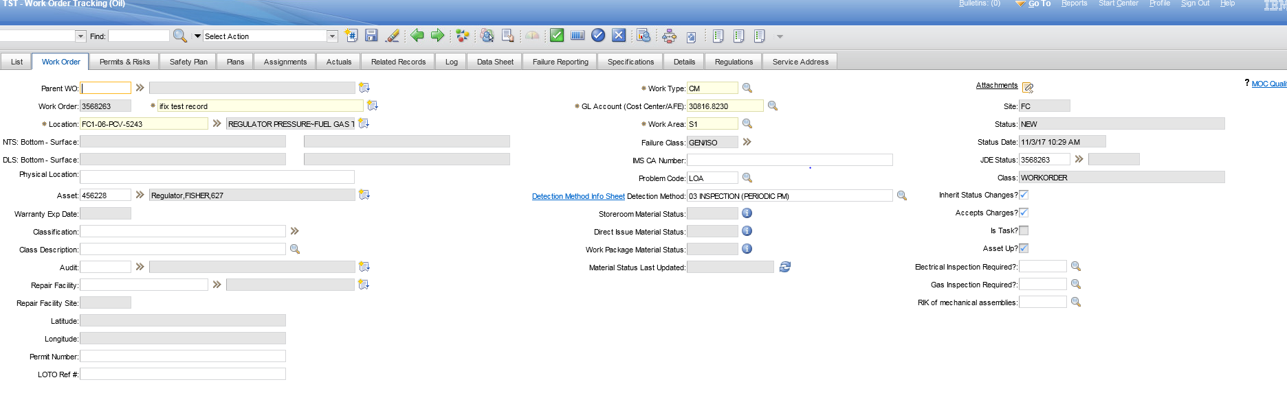

1. Add inventory reservation to Plan tab

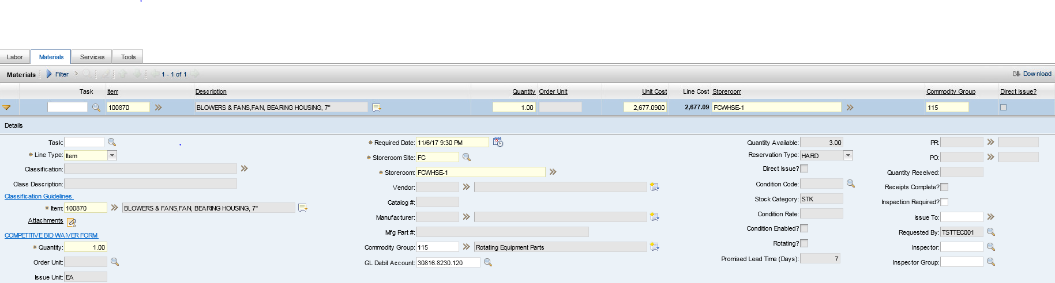

1. Approve the workorder

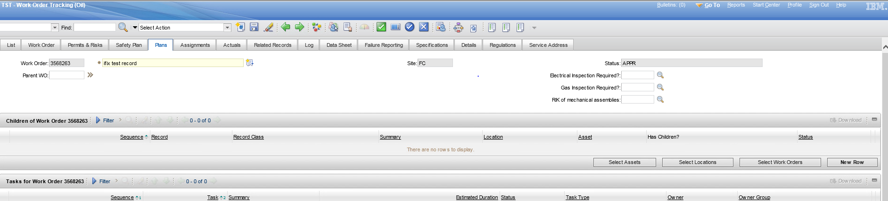

1. Inventory usage record is created

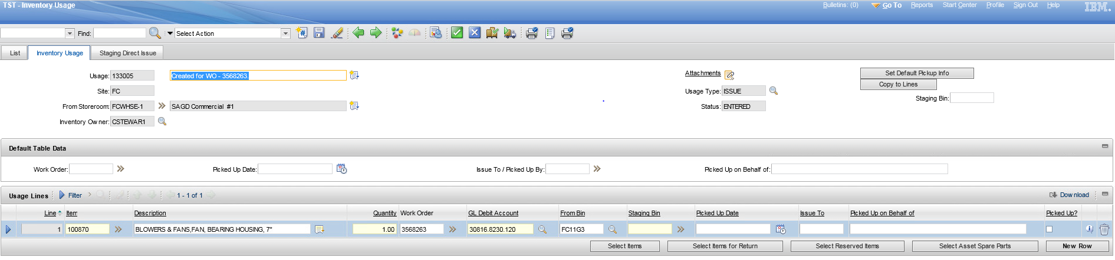

1. Change status of Inventory usage record to STAGED

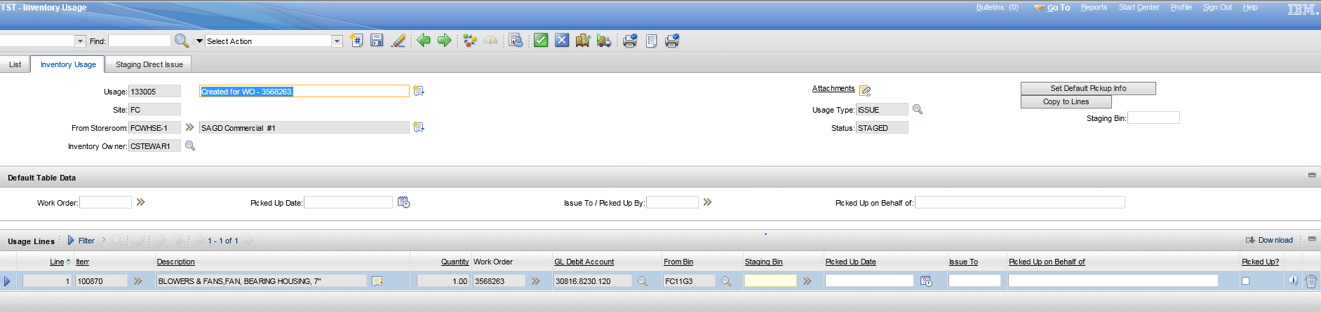

1. Change status of work order to EDIT

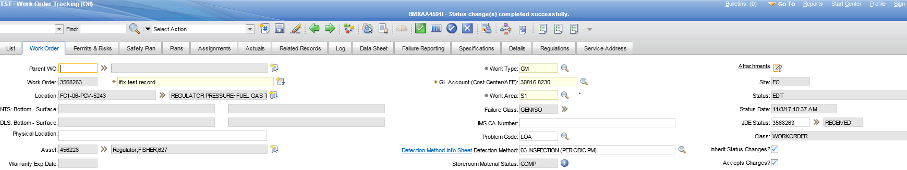

1. Change quantity reserved on the Plan tab

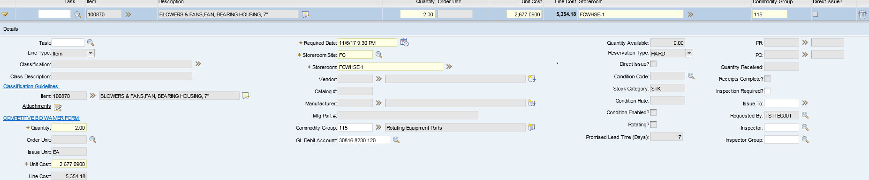

1. Another Inventory usage record is created for the new quantity.  However, the old one is NOT cancelled or deleted.  So two Inventory Usage records now exist – one for the original quantity, and the other for the updated quantity (over-reserved).  This is almost correct.  Since the original one is in Staged status and can’t be updated, a new inventory usage record is correct, but it should be for the difference, not the full reserved quantity.

