**Problem Statement:** Ability to merge Test scripts from within Test case in RQM

**Teams Affected:** All Teams in Onshore Project area

**Application version**: 6.0.6.1 ifix019

**Priority**: High

**Problem:** While merging, the test case changes and test script changes needs to merged separately, even if the test scripts are part of the same test case.

**Description:** One of our team is using a two-stream strategy, 'Initial stream' and 'development stream'.

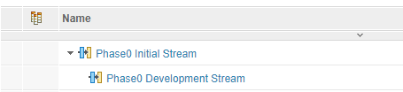

Development stream is used to create/edit/update test cases. These test cases in the development stream will be later merged to the initial stream and the test cases will be executed in the initial stream. During the merge operation the test case changes and test script changes needs to merged separately, even if the test script scripts are part of the same test case.

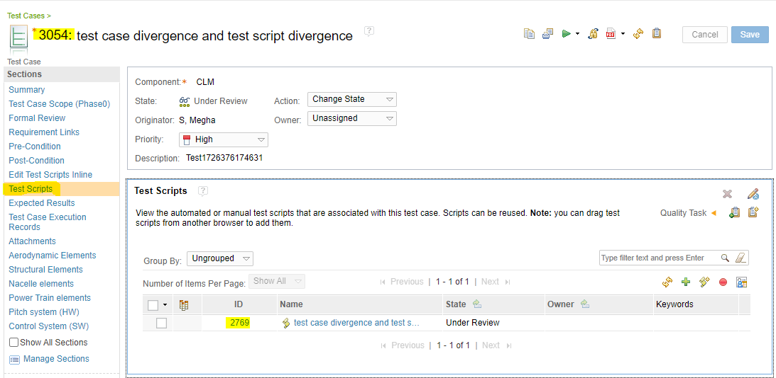

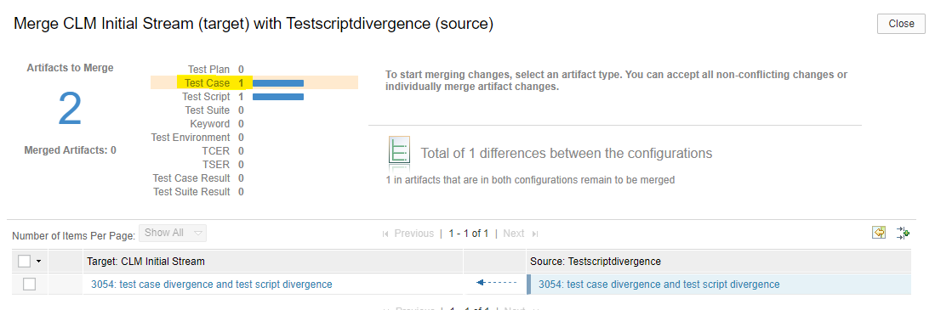

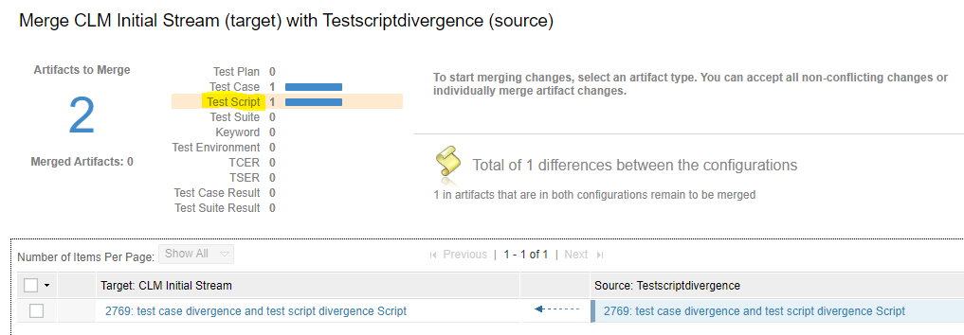

We would like to have the test script changes as a part of test case and merge it from the test case manually instead of having to merge it separately.