Work Order Tracking application
Actuals tab
This WO has 7 Operations. The last one is in progress and the percentage of work is completed at 100%.
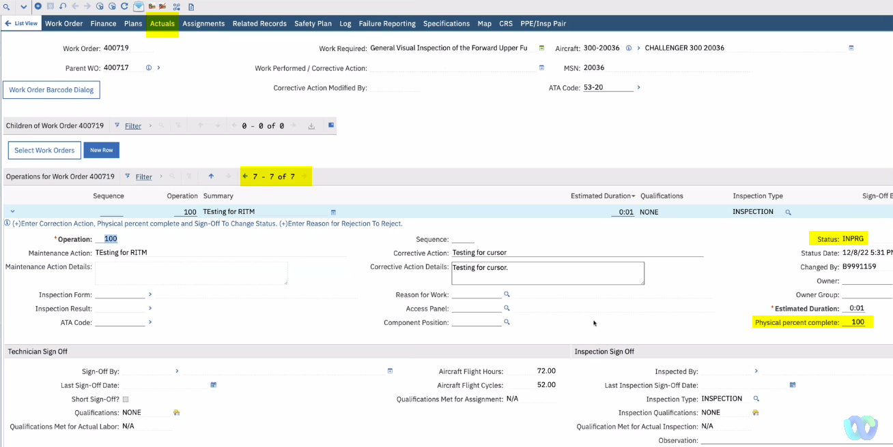

Press the “Sign Off” button.
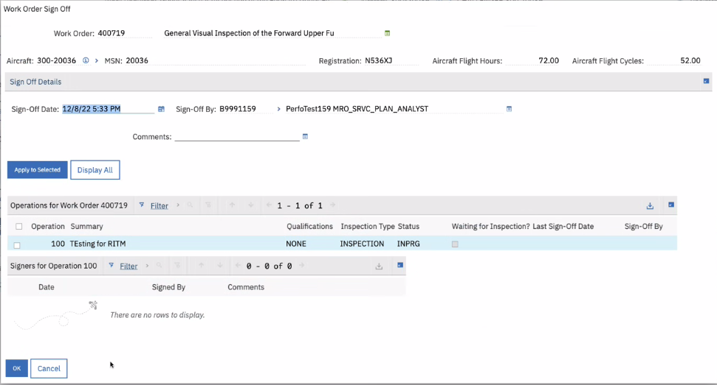
Sign off against the selected operation.
Then, press the “OK” button.

When the “Work Order Sign Off” dialog is closed, the focus is not on the selected Operation but against another operation.
