**Case Request for update**

Our business is having to review each PR line when processing an INVENTORY REORDER. This is because our correct stock levels cannot be achieved by the way the database is using REORDER POINT & REORDER QUANTITY (Reorder Point +1/ EOQ).

Examples,

**PR-4700 and ITEM # NGS-00-0025**

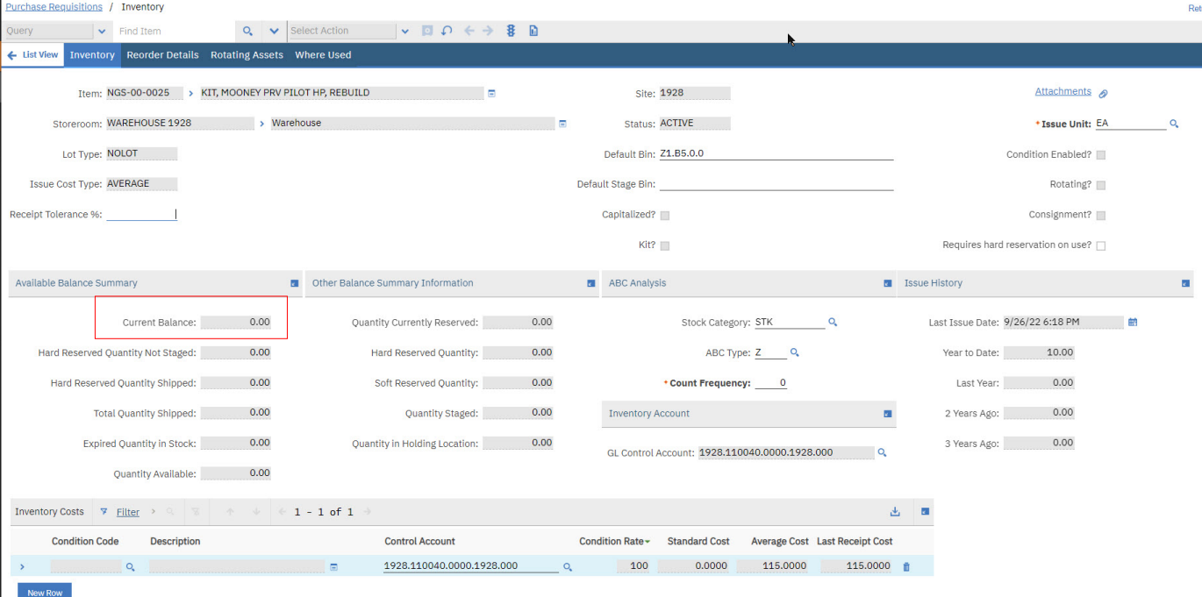

**ITEM # NGS-00-0025,**

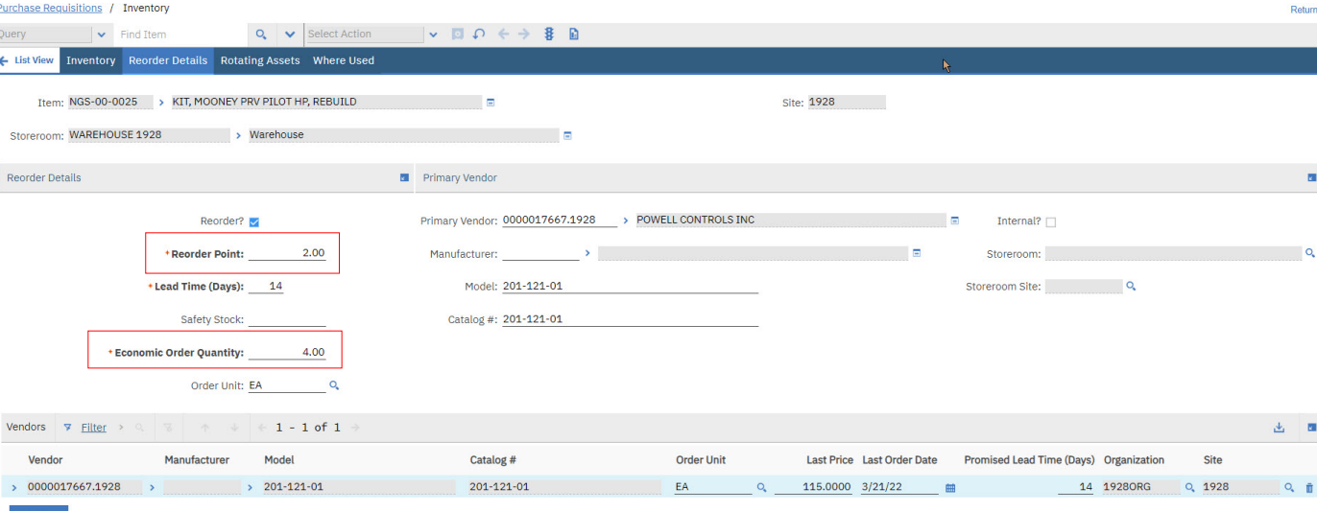

* REORDER POINT is set to (2) with a REORDER QUANTITY set to (4) which would give the user a means of getting the ON-HAND quantity to (6) if the BIN QUANTITY was (0).
* We would expect the system to be calculate the reorder quantity for the INVENTORY REORDER to take the SUM of the two reorder numbers (REORDER QTY / REORDER PT) and know that if you have zero in stock, you need to order (6).
* In the same example, if the BIN QUANTITY was (1) the end user would expect the system to order (5) when the INVENTORY REORDER was processed.
* The PR was manually changed from (4) to (6) so that the current stock would be at desired level of (6) ON-HAND.

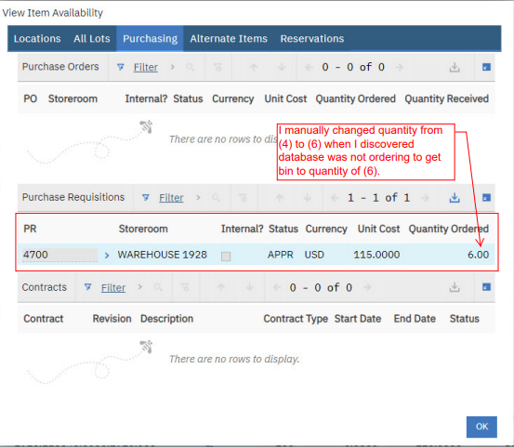

Since these two fields are the only ones that the end user can input for stock levels, this is creating a lot of extra work to have users to review each and every PR Line for INVENTORY REORDERS to make sure the desired stocking levels will be reached.

Using the current calculation and the reality of our national current state of extended lead times, our plants be much more at risk of diminished stock. Conversely, we do not want to overstock as this also has financial impacts.

In an older versions or Maximo, the end user had (3) fields that were used to set up the appropriate stocking levels and it worked flawlessly with the proper calculations when processing INVENTORY REORDERS.

The fields were : MIN QTY, REORDER QTY and MAX QTY (BIN MAX).  If the BIN was below your MIN QTY, Maximo would process a reorder to get you back to your BIN MAX QTY.

The way the current MAXIMO Inventory Reorder process calculates, you will never get to a BIN Max level of stock since the calculation doesn't work effectively like it used to prior to their code changing.

At minimum-

For flexibility for Your customer’s specific business processes, there could be value in configuration setup to allow your Maximo customer the ability to determine if they would rather use EOQ process as Maximo/IBM have it today, or in our case the value of a simple Min/Max calculation.