In 7.6 it used to be more visible.

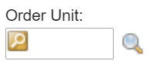

In MAS

