**IBM case TS011111439 leading to Defect PH51124 -> Code review workflow is not consistent across code review cycles**

* Defect PH51124 link: <https://jazz.net/jazz/web/projects/Rational%20Team%20Concert#action=com.ibm.team.workitem.viewWorkItem&id=559432>

**What is the expected output? Code review for cycle 1 and cycle 2 must be consistent.**

Defect design 567678 (No APAR number issued):

<https://jazz.net/jazz/web/projects/Rational%20Team%20Concert#action=com.ibm.team.workitem.viewWorkItem&id=567678>

**Fixing defect design 567678 will not fix Defect PH51124 and would not make Code review for cycle 1 and cycle 2 consistent.**

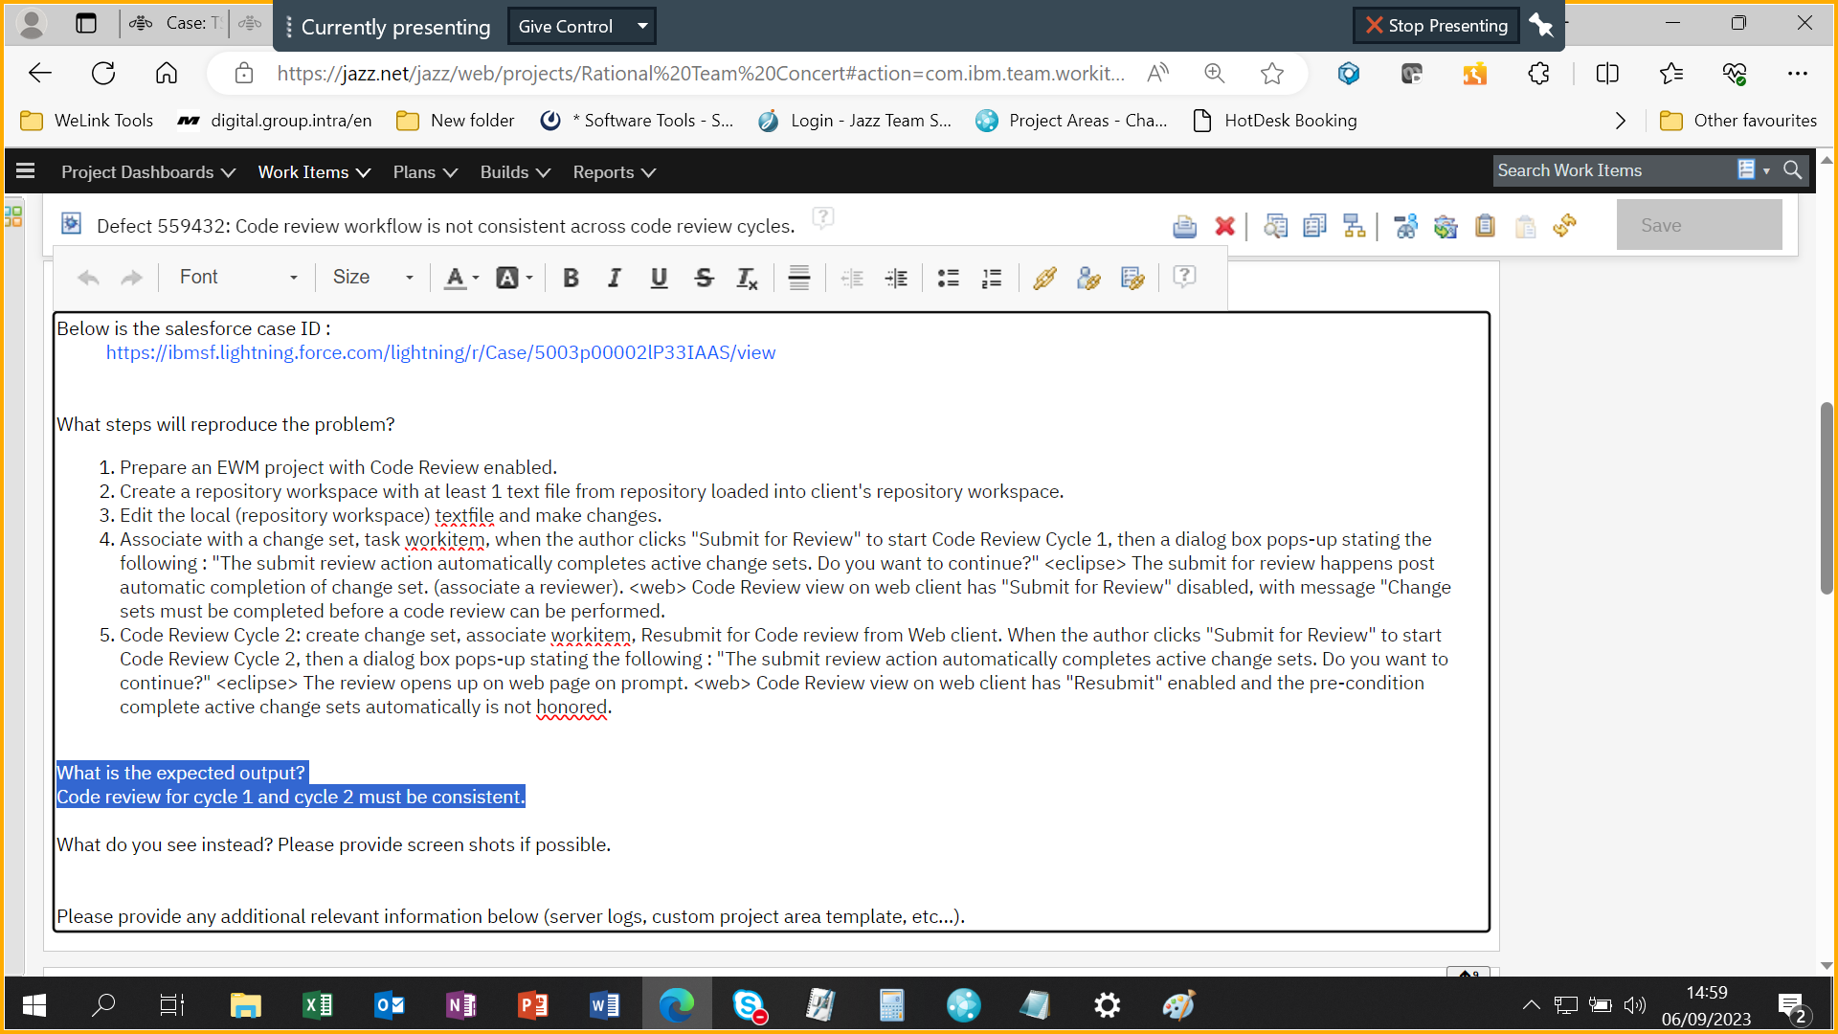

|  |  |  |
| --- | --- | --- |
| **Original Inconsistent behaviour with v7.0.2 without any ifix** | **Inconsistent behaviour after partially fixing Defect PH51124 in v7.0.2 ifix19** | **Required to fix the inconsistency**  **Code review for cycle 1 and cycle 2 must be consistent** |
| ***Code Review cycle 1***:   1. Author logs into Eclipse client 2. Author creates change set 3. Author associates with work item say 123 4. Author clicks “Submit for review” button from Eclipse client.   **Code Review cycle 2 onwards**:   1. Author logs into Eclipse client 2. Author creates change set 3. Author associates with work item say 123 4. Author clicks “Complete” button from Eclipse client. 5. Author clicks “Submit for review” button from Eclipse client. 6. Author has to additionally open EWM Web client. 7. Login into Web client 8. Select the “**Review**” tab 9. Click on “**Resubmit**” button. | ***Code Review cycle 1***:   1. Author logs into Eclipse client 2. Author creates change set 3. Author associates with work item say 123 4. Author clicks “Submit for review” button from Eclipse client.   **Code Review cycle 2 onwards**:   1. Author logs into Eclipse client 2. Author creates change set 3. Author associates with work item say 123 4. Author clicks “**Submit for review**” button from Eclipse client and then a pop-up comes up saying “***A code Review with the status “In Revision” already exists for work item xxx. Do you want to open the code review? Open Code Review or Cancel”***   ***Based on iFix24***   1. Author has to additionally open EWM Web client. 2. Login into Web client 3. Select the “**Review**” tab 4. Click on “**Resubmit**” button. | ***Code Review cycle 1***:   1. Author logs into Eclipse client 2. Author creates change set 3. Author associates with work item say 123 4. Author clicks “Submit for review” button from Eclipse client.   **Code Review cycle 2 onwards**:   1. Author logs into Eclipse client 2. Author creates change set 3. Author associates with work item say 123 4. Author clicks “Submit for review” button from Eclipse client. |

*On second Code Review attempt by the author from Eclipse client, the pop message reads as ***“The pop message reads, “A code Review with the status “In Revision” already exists for work item xxx. Do you want to open the code review?” .*** *The UI pop-up message is ambiguous to user as it is unclear they have to open the code review to resubmit as a mandatory step.* The IBM documentation is also inaccurate and ambiguous

