WIDE REPORTS CUT OFF ON RIGHT SIDE WHEN EMAILING SCHEDULED REPORTS AS ATTACHMENTS
When a report is scheduled to be run and sent by email to a recipient as a PDF file and the report is very wide, the right side of the report gets cut off in the email attachment. When the same report is run and exported as a PDF file from Maximo from the BIRT Report Viewer using the Export Report button, the user is given the opportunity to set a Fit To property to Actual Size, which allows the entire width of the report to be exported. Is there a way to set Maximo to send scheduled reports through email to be set to Actual Size by default? If not, could this capability be provided in the future, possibly allowing the selection when the report is being scheduled?
- Go to Work Order Tracking and use the Run Reports action to create an ad hoc report. Call the report WORK ORDERS.
- The report should have the following attributes selected:
  - Work Order
  - Description
  - Location
  - Asset
  - Status
  - Scheduled Start
  - Priority
  - Dynamic Job Plan Applied
  - Site
  - Reported Date
  - Crew
  - Lead
  - Work Type
  - Job Plan
  - PM
  - Actual Start
  - Actual Finish
  - Actual Labor Cost
  - Actual Labor Hours
  - Actual Material Cost
  - Actual Service Cost
- Run and Save the report.
- Export the report to a PDF format. Leave the Fit To set as Auto. The exported report looks like this:
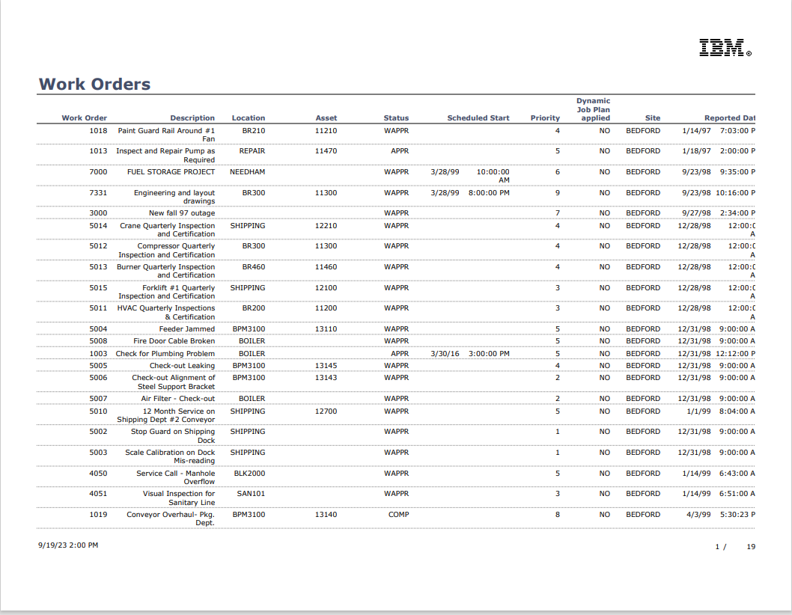
- The report is cut off at the Reported Date column.
- Export the report again, but select the Actual Size option under Fit To. The exported report looks like this:
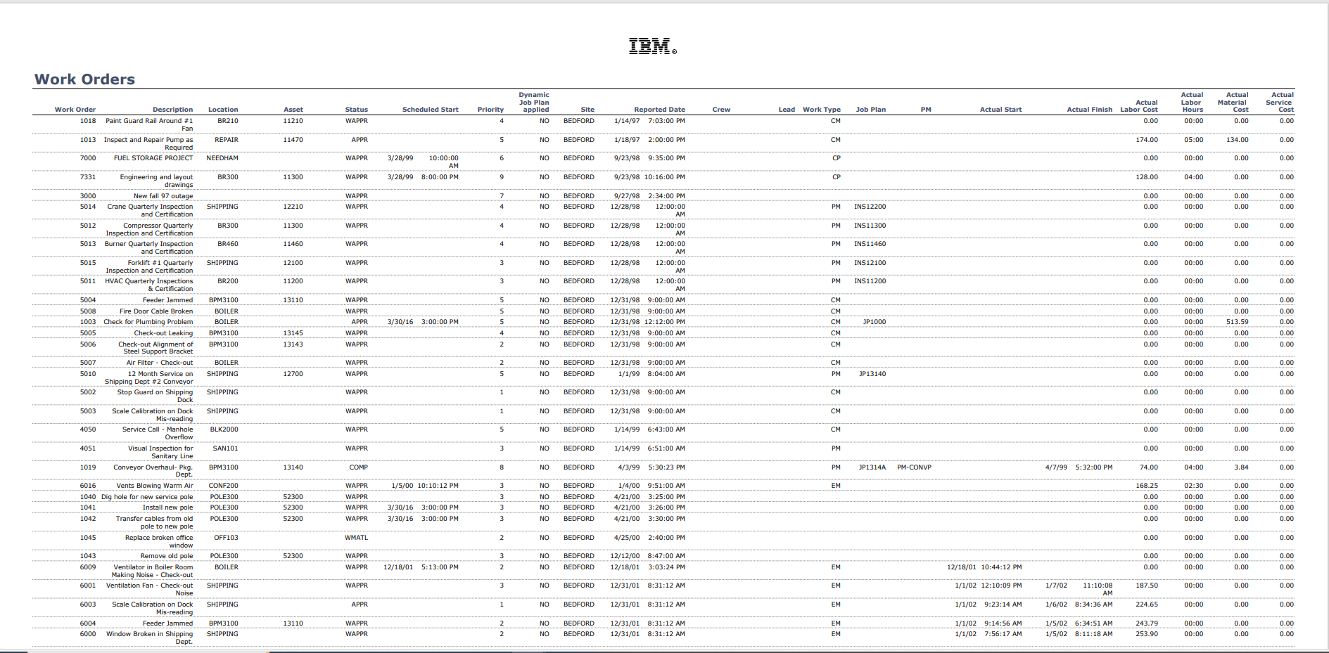
- The full report is scaled to show the entire width of the report.
- Schedule the report to be run at a point in the future to the emailed as an attachment to an email.
- Let the report run.
- Check the report attached to the email. This is what it looks like:
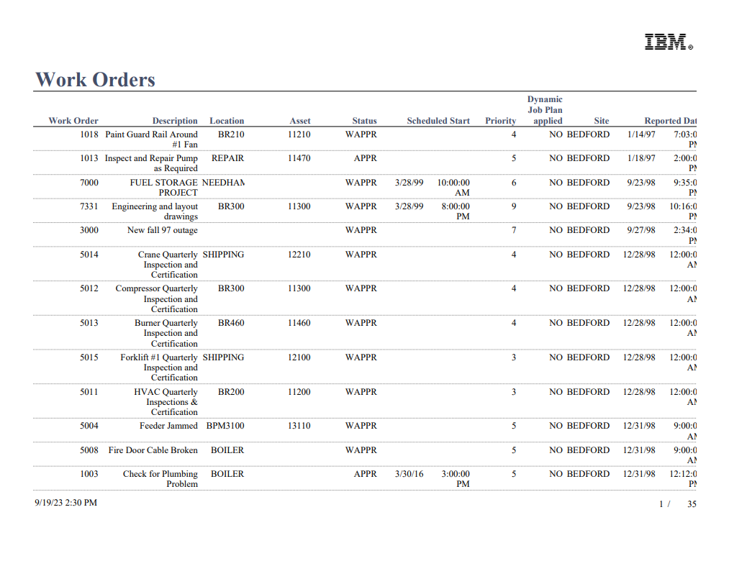
- Unlike when the report is exported manually using the Export Report button, there is no opportunity to set the Fit To setting to Actual so the entire width of the report is visible.

