Current System Configuration.

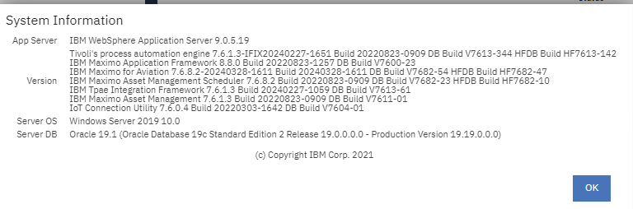

Work Order Tracking Screen

