IBM Idea
– Improved information about received costs

Preface
Being the GL Account Owner (GAO) and by that the budget responsible, It’s important to me that all my approvals and receiving actions come with very clear information. Doing approx. 240 PO approvals followed by same 240 receiving actions I can’t have my solar powered table calculator to help me – I need to trust that Maximo informs me exactly what I’m about to respectively approve and receive.

Benefits from having this idea become reality
When doing receipts the GAO will know the exact cost in correct currency he is about to receive. This is not the case As-Is.

Receiving As-Is
Looking into how receiving works today, as a GAO I find these two (different) tabs

Materials
When doing materials receipt, the GAO isn’t informed about which kind of cost he is about to receive. Nor is he informed about which currency.
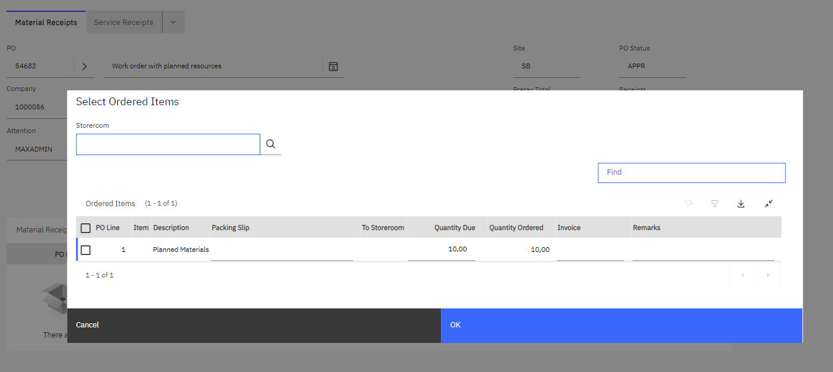
Figure 3: Receiving materials.

Services
When receiving services, the GAO is presented to additional information. However, the “Line Cost Due” doesn’t react to the change in “Quantity Due”.
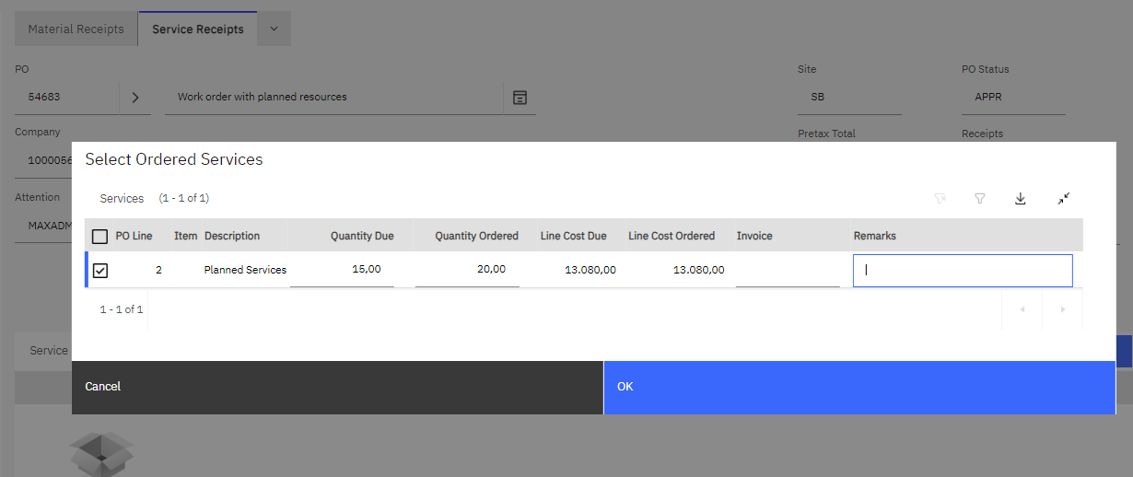
Figure 4: Even though this receipt is partial, the "Line Cost Due" doesn't change. Moreover, the GAO can't see with which currency his is working.

Receiving To-Be
Please ensure to have these fields are represented when doing receipts:
PO Line | Item | Description | Packing Slip | To Storeroom | Quantity Due | Quantity Ordered | Line Cost Due | Line Cost Ordered | Currency | Invoice | Remarks
Please ensure to have the “Line Cost Due” to adjust to the value set in the field “Quantity Due”.
The fields “Packing Slip” and “To Storeroom” only exist when doing Material receipts.
--##--

