Error Handling for Integration Redesign Solution

Objective
This document provides a detailed, step-by-step guide for incorporating error handling in synchronous inbound, asynchronous inbound/outbound, and synchronous outbound transactions as part of the MAS Integration Redesign Solution.

Error Handling Overview
Integration Points | Error Handling Application | Configurations needed | Comments
Asynchronous Outbound | Message Tracking  Filter by integration component(Publish channel) name to check transaction status. | Publish channel à More actionsà Message tracking à Enable message tracking and Store messages | Refer below 1.1 screen Reference
Asynchronous Inbound | Message Tracking  Filter by integration component name(Enterprise service) to check transaction status. | Enterprise Service à More actionsà Message tracking à Enable message tracking and Store messages | There are no Async inbound trasactions in current integration redesign  Refer below 1.2 screen Reference
Synchronous Inbound | Message Tracking  Synchronous message tracking | Message Tracking:  - Set mxe.int.storerestmsg to 1  - Set mxe.int.trackrestrequests to 1  Save and perform live refresh for above properties | Refer below 1.3 screen Reference
Synchronous Outbound | No application to track errors | NA | Exploring on solution to track sync outbound transactions via invocation channel

1.1 Screen reference of message Tracking for Asynchronous Outbound Integration
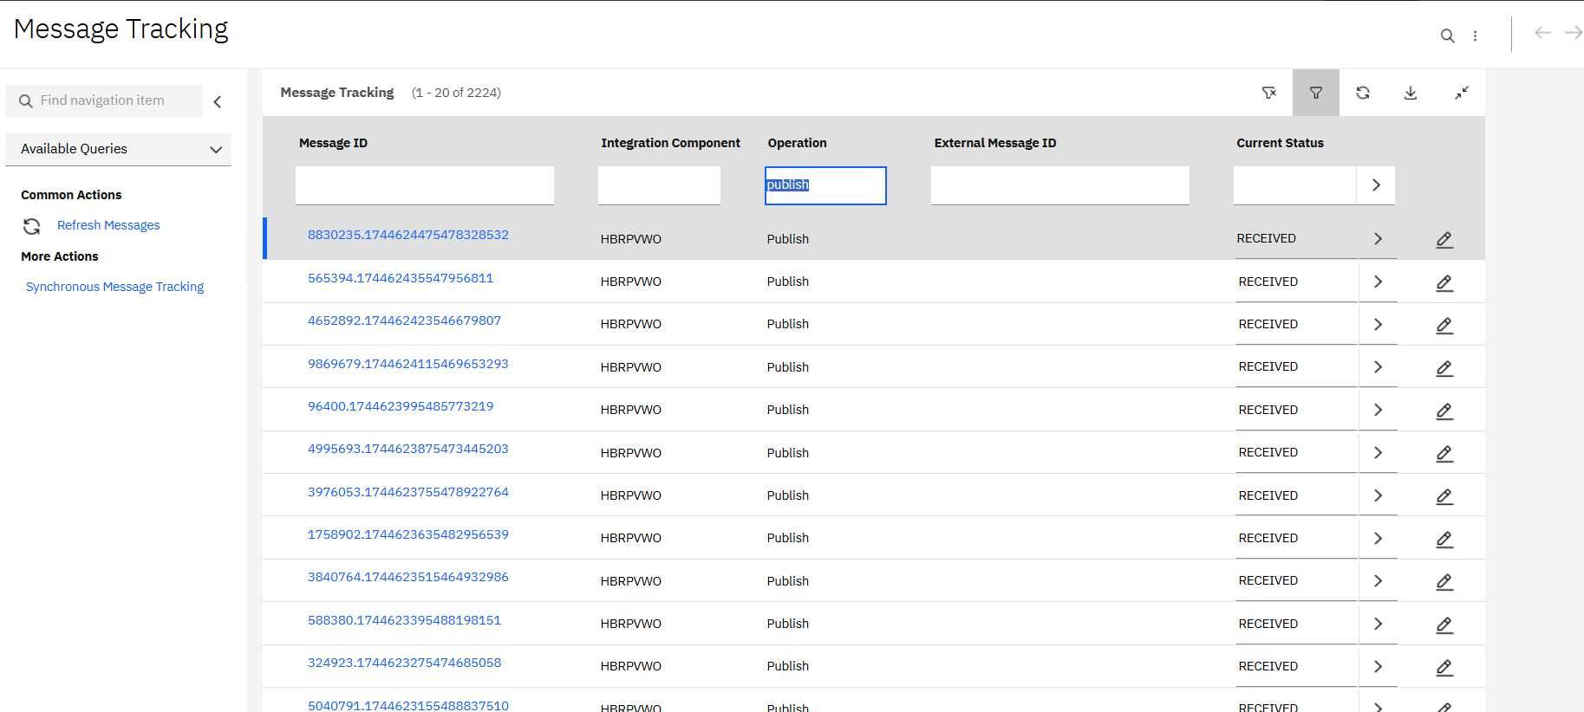
1.2 Screen reference of message Tracking for Asynchronous Inbound Integration
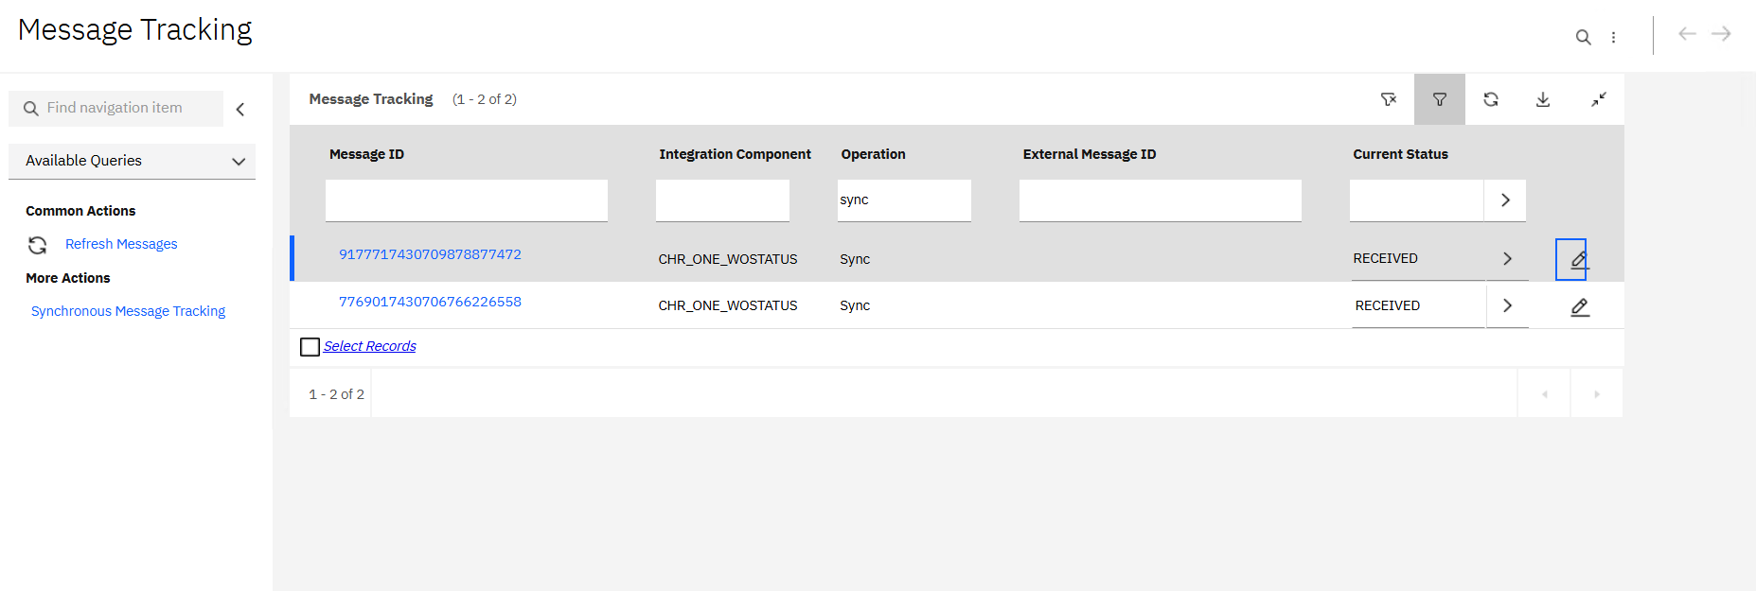
1.3 Screen Reference of message tracking for Synchronous Inbound integration
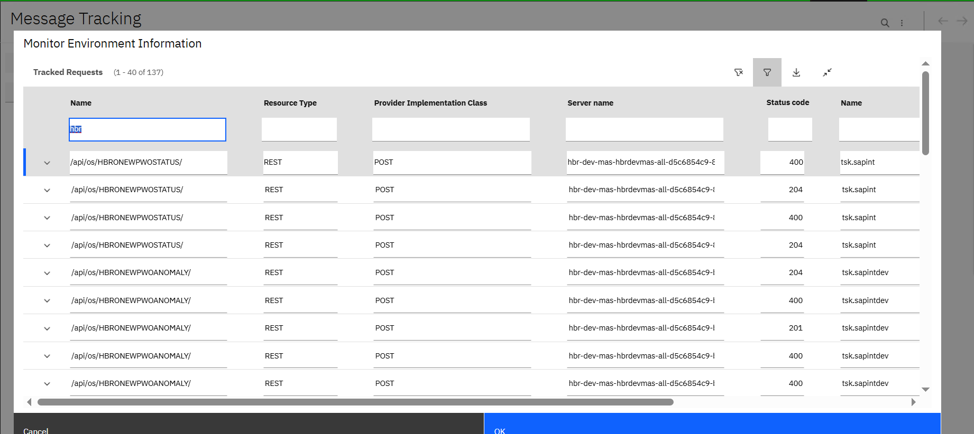

Asynchronous processing for outbound from publish channel

Error Tracking/ Reprocessing:
- Message Generated: Maximo publishes an outbound message from the publish channel through a cron task or event listener.
- Queued for Processing: The message is placed in the JMS queue.
- Cron Task Processing: The JMSSEQCONSUMER cron task picks up the message and attempts processing to the Endpoint.
- Error Occurrence: If an error occurs during transformation, validation, or delivery, it is logged in message Tracking.
- The error is logged in Message Tracking with status "Error". 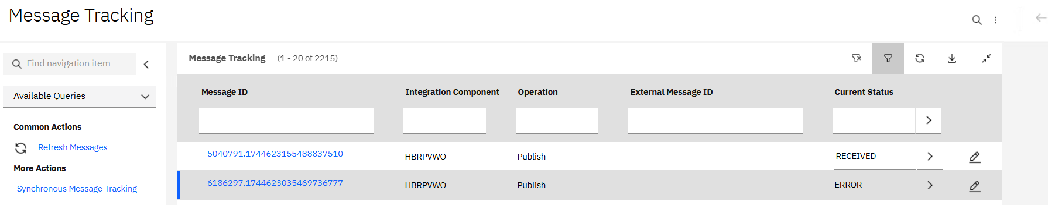
- Users can manually correct the data and reprocess the failed message from Message Reprocessing application.
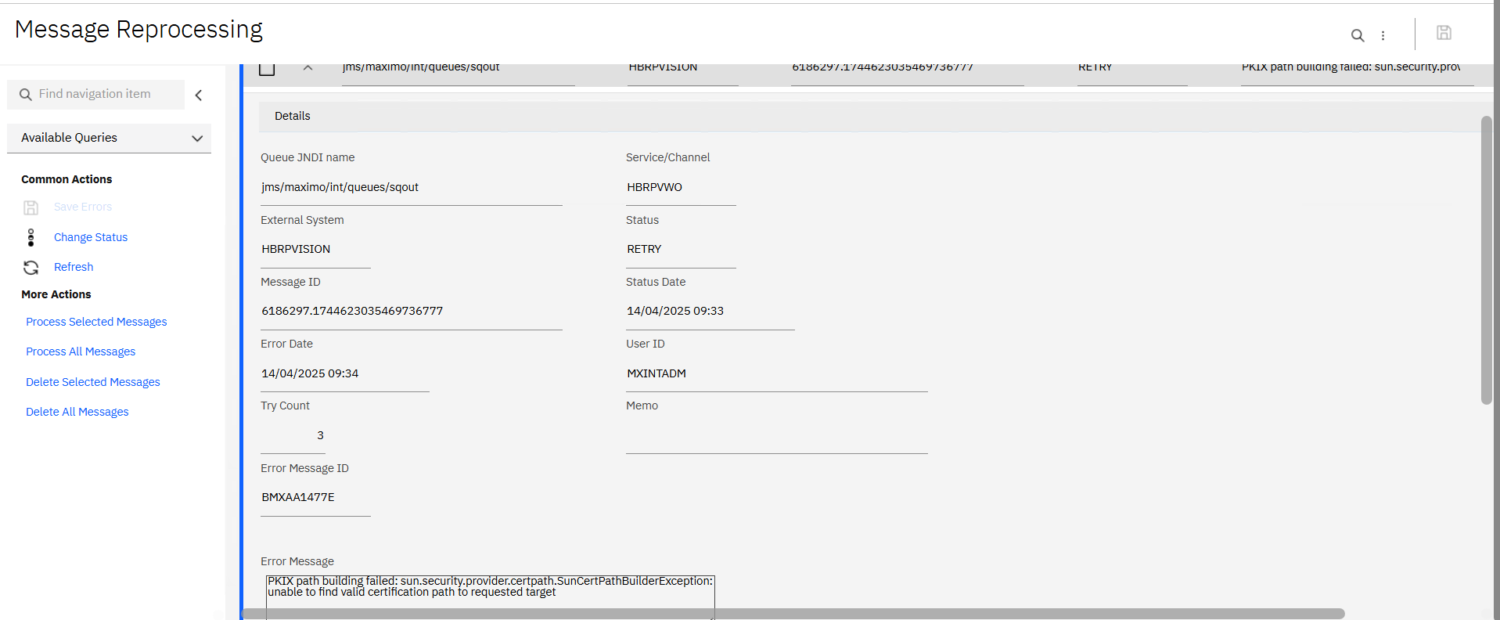

Asynchronous processing for INBOUND from Enterprise Service:
There are no current Asynchronous inbound transactions in current integration redesign.

Error Tracking/ Reprocessing:
- Message Generated: Inbound message which comes from external system through enterprise service.
- Queued for Processing: The message is placed in the JMS queue.
- Message Driven Beans/Cron Task processing: The continous queue or the JMSSEQCONSUMER cron task picks up the message and attempts processing to the Maximo.
- Error Occurrence: If an error occurs during transformation, validation, or delivery, it is logged in message Tracking.
- The error is logged in Message Tracking with status "Error".
- Users can manually correct the data and reprocess the failed message from Message Reprocessing application.

Synchronous Inbound Processing

Error Tracking/ Reprocessing:
- Request Sent: Send a REST request to Maximo via Postman, mirroring the approach used by the peripheral system.
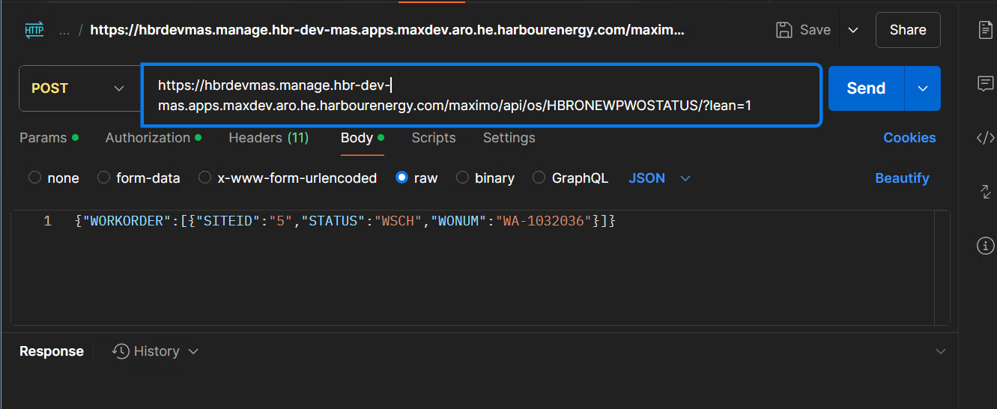
- Validation & Processing: Maximo validates data using the MBO layer. If automation scripts or custom logic exist, they are executed.
- Error Occurrence: If an error occurs (e.g., invalid attribute), Maximo throws a system or business exception immediately.
- Navigate to message tracking> synchronous message tracking from more actions.
- Filter with object structure name and you can find the error message getting logged in.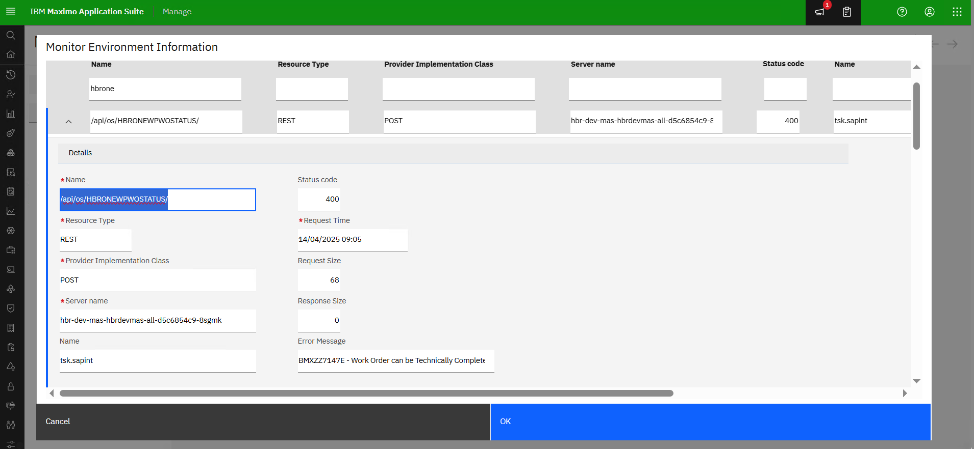

- After identifying the error, the appropriate fix must be determined, and the message needs to be manually reprocessed.
- The same error response will also be returned to POSTMAN.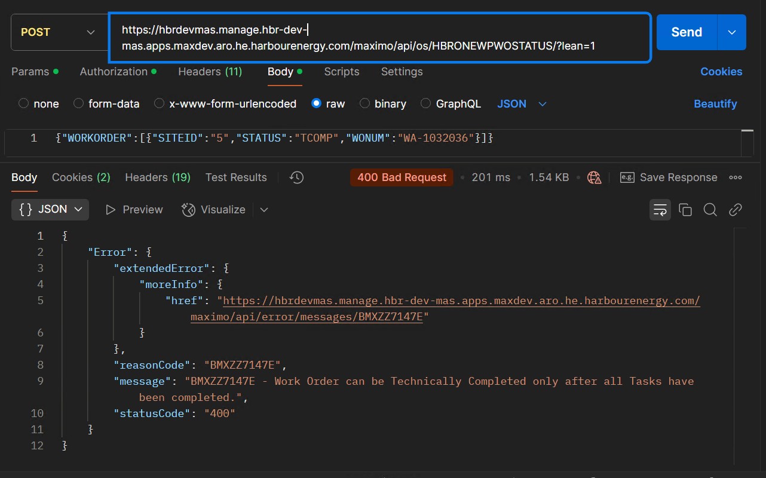

Synchronous processing for outbound from invocation channel

Error Tracking/ Reprocessing:
Currently, there is no application in place to track errors directly from the UI. At present, error tracking is managed through Maximo system logs. We are actively exploring a solution to enable error tracking.
- Message Generated: Maximo publishes an outbound message from the invocation channel through a cron task.
- This message directly hits the API URL of the peripheral system.
- Error Occurrence: If an error occurs during transformation, validation, or delivery, it is getting logged in Maximo System Logs.
- Include logger statements in the automation script to capture errors and review through the log files.
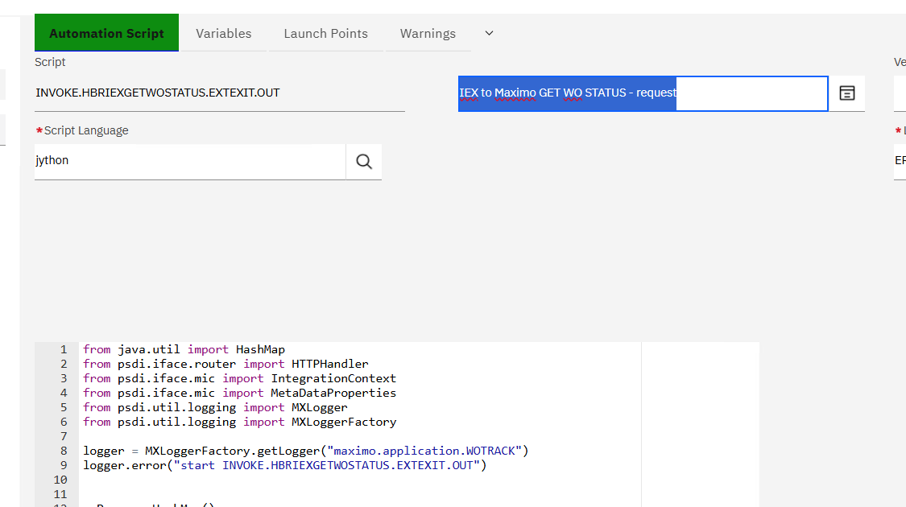
- The logger statements below capture the URL being accessed and the corresponding error response received from the peripheral system
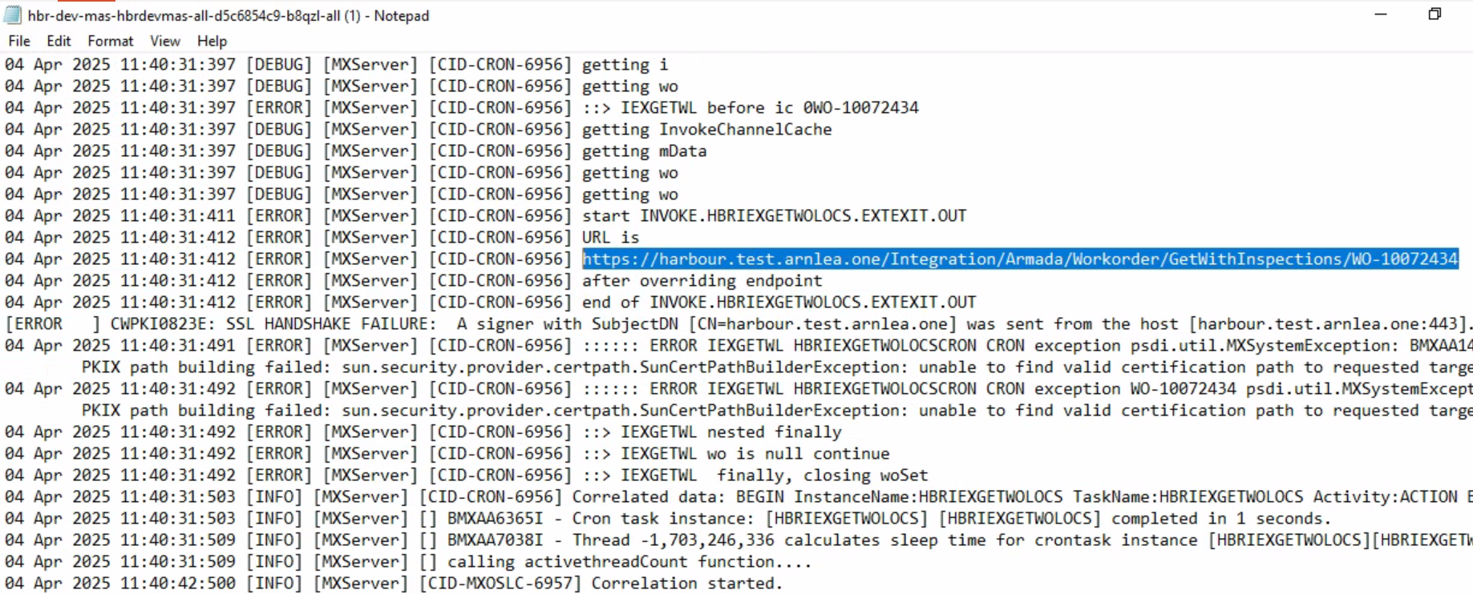

But we are not able to capture this error message in synchronous message tracking for outbound transacctions .

