IBM Maximo Request for Enhancement (RFE)
Title: Enable Job Plan Duration Propagation to WO Estimated Duration from Route Stops used as MALCI Entries
Version: [ MAS 8.10.23][Manage 8.6.23]
Component: Work Management / Routes / Job Plans

Current Behavior
When creating a Work Order (WO) from a Route with Route Stops that have the " Child Workorders" option enabled, and each route stop is linked to a Job Plan, the task durations from each Job Plan are correctly inherited into the resulting child WOs. These durations are also summed up and reflected as the total Estimated Duration on the parent Work Order.
However, if the Route Stops are instead converted into Multiple Asset, Location and CI (MALCI) entries within a Work Order (i.e., the “Entries in the Work Order’s Multiple Asset, Location and CI table” option is used), the Job Plan field on each route stop becomes read-only. This prevents the association of Job Plans to those entries, and as a result, no estimated duration is populated in the Work Order.

Expected Behavior
The system should allow Job Plan associations for Route Stops even when converted to MALCI entries. Based on those Job Plans, Maximo should sum the task durations and populate the parent Work Order's Estimated Duration field accordingly, similar to the behavior seen when "Create Child WOs".

Suggested Enhancement
- Make the Job Plan field editable for Route Stops, even when the route is configured to create MALCI entries.
- On WO creation, if a Job Plan is associated with the route stop:
- Retrieve the task durations from that Job Plan.
- Add them to the total Estimated Duration on the parent WO.
- Optionally, display a breakdown of estimated durations per MALCI entry for audit and planning purposes.

Attachments
- Screenshots of Route Stop configuration
Child Workorders
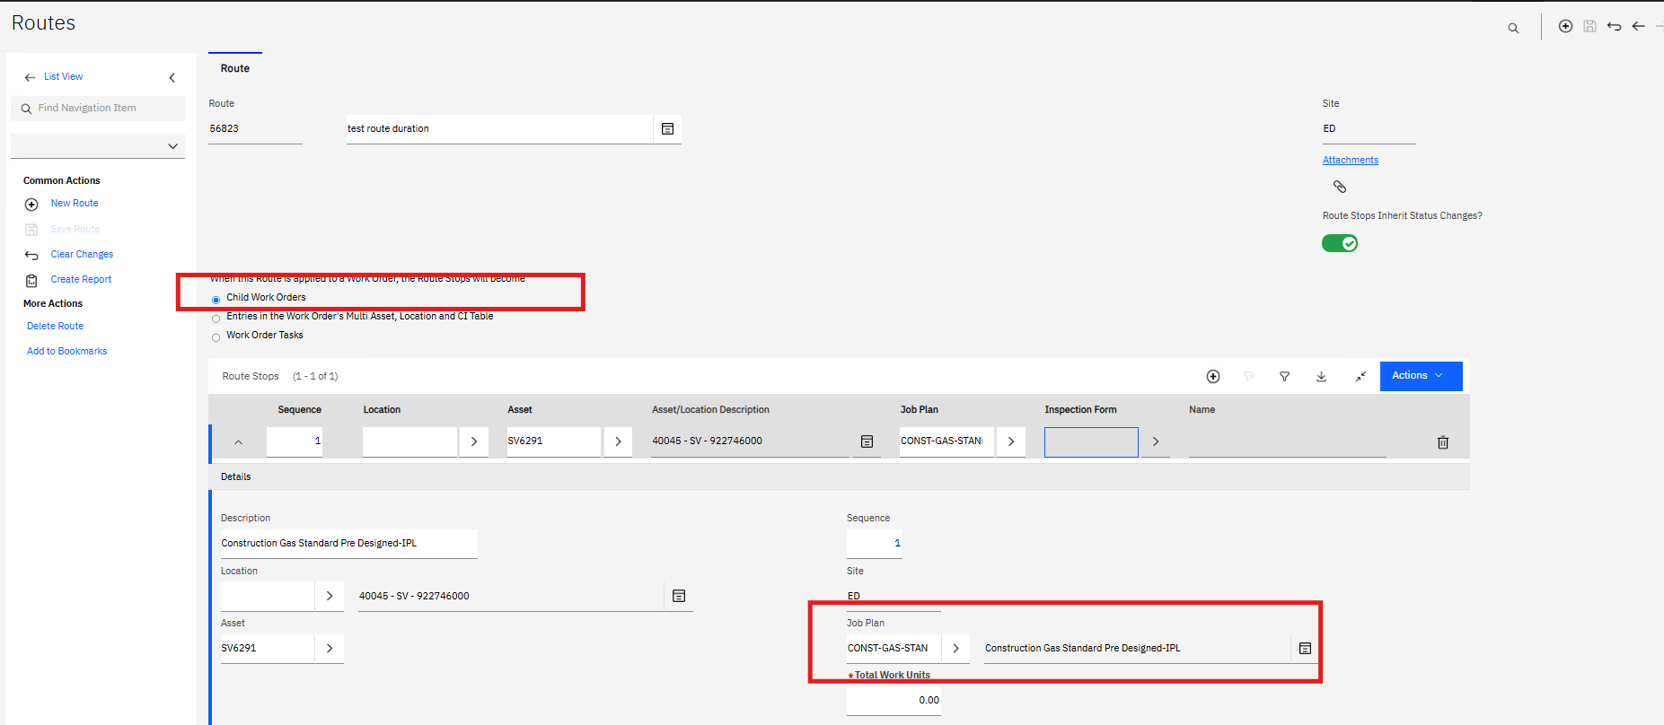

Entries in the Work Order's Multi Asset, Location and CI Table
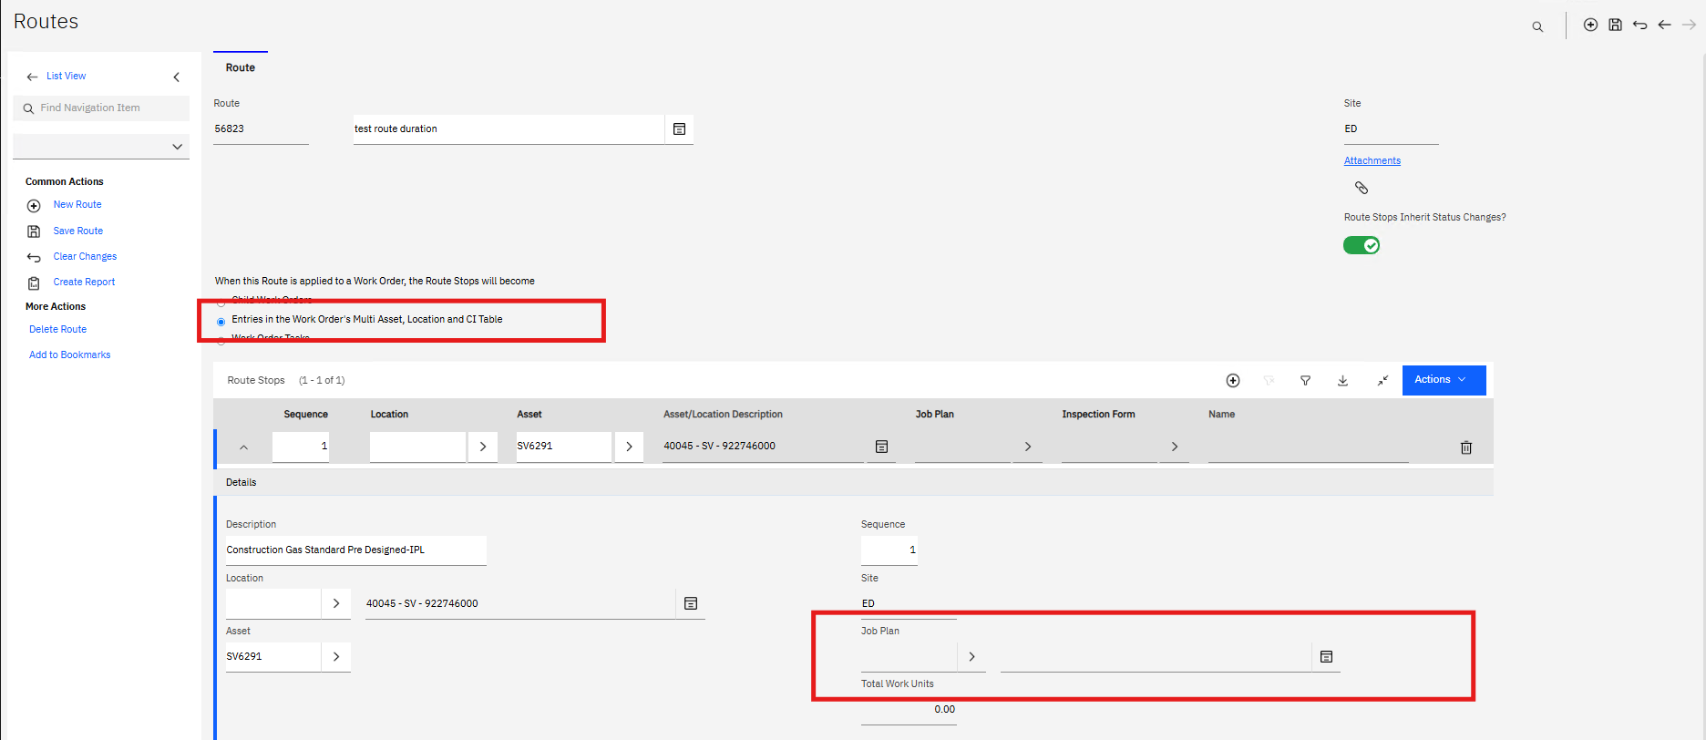

Conclusion
This enhancement will improve consistency in work planning, reduce manual effort, and align functionality across all route application methods within Maximo.

