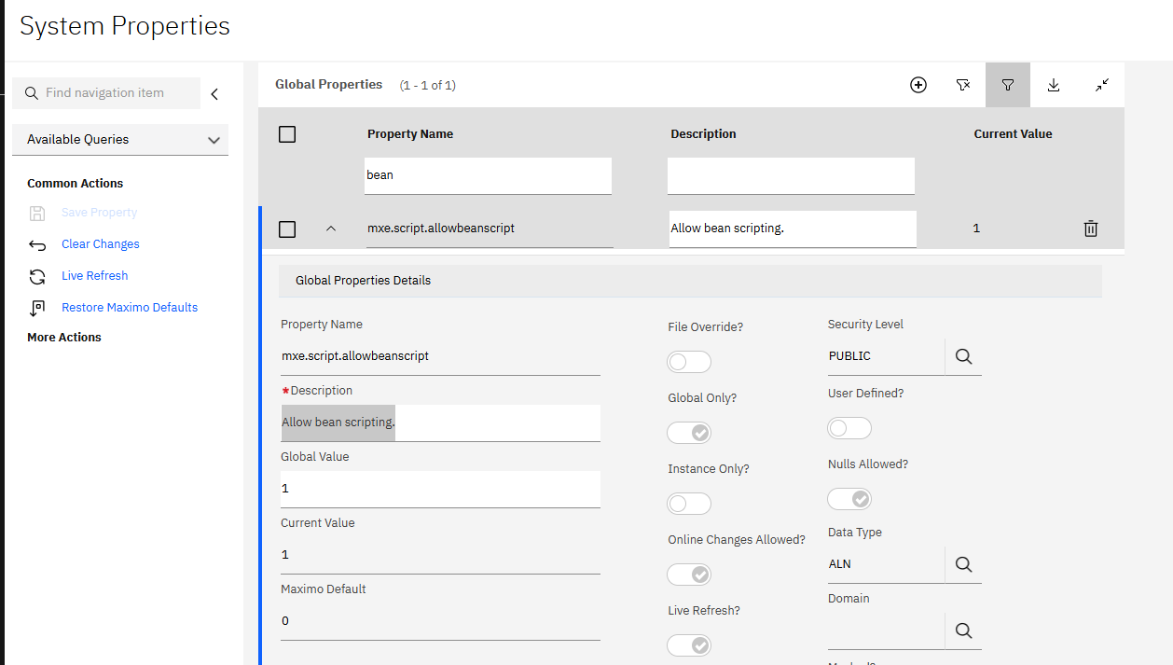
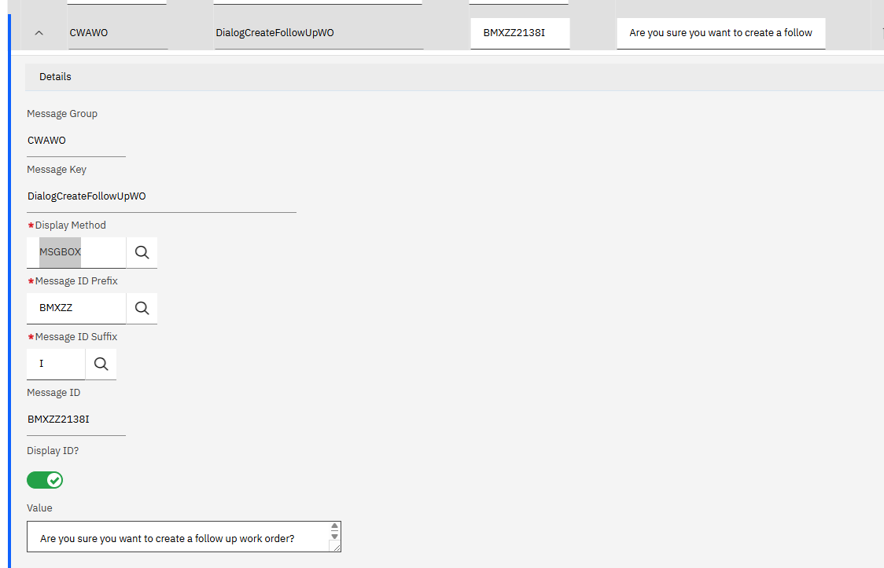
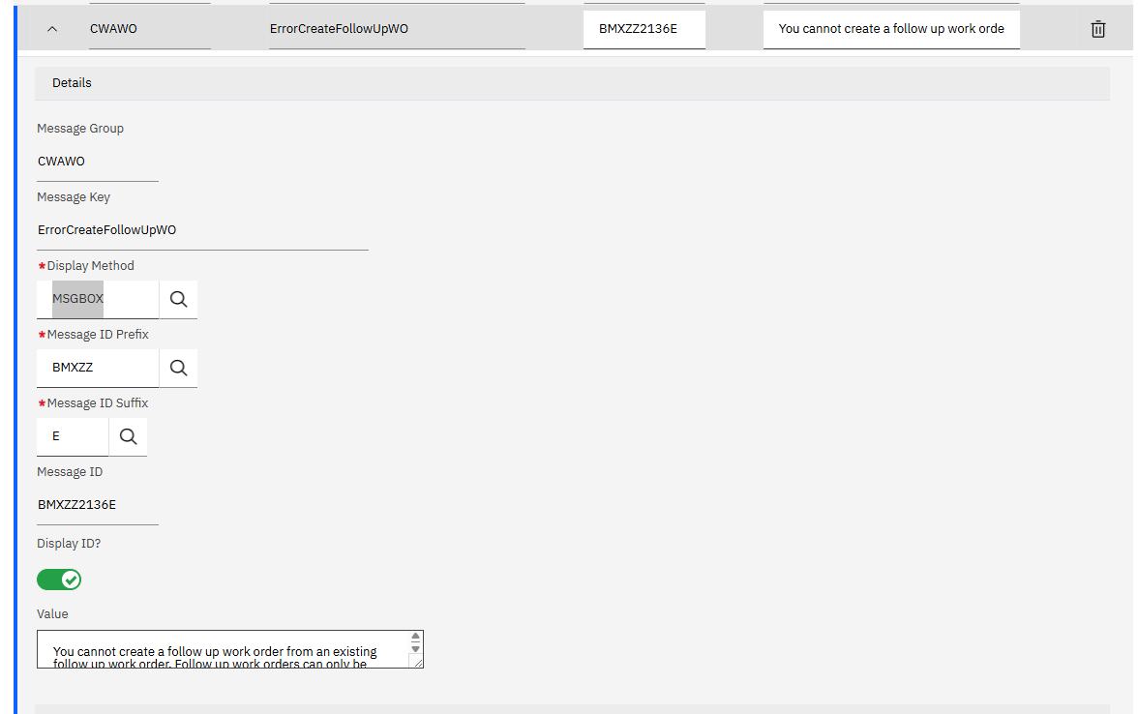
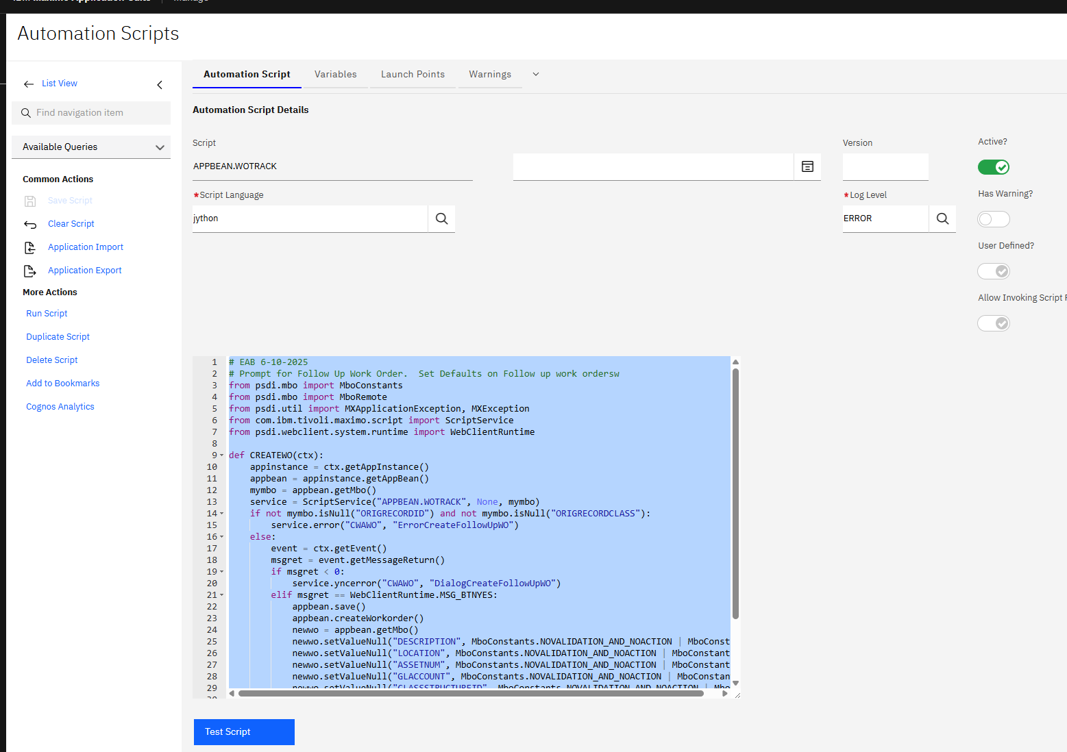

# EAB 6-10-2025
# Prompt for Follow Up Work Order. Set Defaults on Follow up work ordersw
from psdi.mbo import MboConstants
from psdi.mbo import MboRemote
from psdi.util import MXApplicationException, MXException
from com.ibm.tivoli.maximo.script import ScriptService
from psdi.webclient.system.runtime import WebClientRuntime

def CREATEWO(ctx):
appinstance = ctx.getAppInstance()
appbean = appinstance.getAppBean()
mymbo = appbean.getMbo()
service = ScriptService("APPBEAN.WOTRACK", None, mymbo)
if not mymbo.isNull("ORIGRECORDID") and not mymbo.isNull("ORIGRECORDCLASS"):
service.error("CWAWO", "ErrorCreateFollowUpWO")
else:
event = ctx.getEvent()
msgret = event.getMessageReturn()
if msgret < 0:
service.yncerror("CWAWO", "DialogCreateFollowUpWO")
elif msgret == WebClientRuntime.MSG_BTNYES:
appbean.save()
appbean.createWorkorder()
newwo = appbean.getMbo()
newwo.setValueNull("DESCRIPTION", MboConstants.NOVALIDATION_AND_NOACTION | MboConstants.NOACCESSCHECK)
newwo.setValueNull("LOCATION", MboConstants.NOVALIDATION_AND_NOACTION | MboConstants.NOACCESSCHECK)
newwo.setValueNull("ASSETNUM", MboConstants.NOVALIDATION_AND_NOACTION | MboConstants.NOACCESSCHECK)
newwo.setValueNull("GLACCOUNT", MboConstants.NOVALIDATION_AND_NOACTION | MboConstants.NOACCESSCHECK)
newwo.setValueNull("CLASSSTRUCTUREID", MboConstants.NOVALIDATION_AND_NOACTION | MboConstants.NOACCESSCHECK)
newwo.setValueNull("WORKTYPE", MboConstants.NOVALIDATION_AND_NOACTION | MboConstants.NOACCESSCHECK)
newwo.setValueNull("SUPERVISOR", MboConstants.NOVALIDATION_AND_NOACTION | MboConstants.NOACCESSCHECK)
appbean.refreshTable()
appbean.fireDataChangedEvent()
return ctx.setEventHandled()
return ctx.setEventHandled()

