Market based emissions report

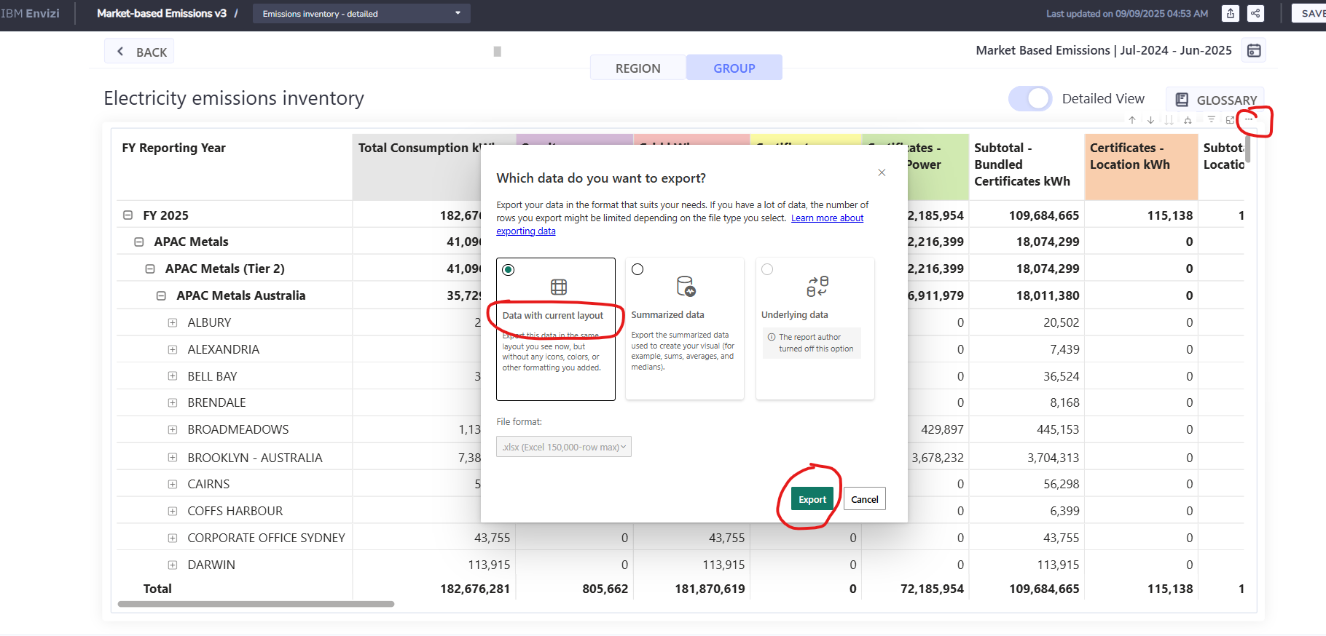

How can I auto setup a report scheduler to extract the market-based inventory table in an xls or csv format. Currently it can only extract to pdf but it's a tabular report and in detail level it cuts off the tabs. For reporting purpose being able to auto schedule a report in xls or csv would be of benefit. Is there a report that I can utilise and setup with this functionality to csv/xls?

The table of information down to account level is a lot more useful in xls or csv format to accommodate aggregations for ESG and audit reporting purposes.

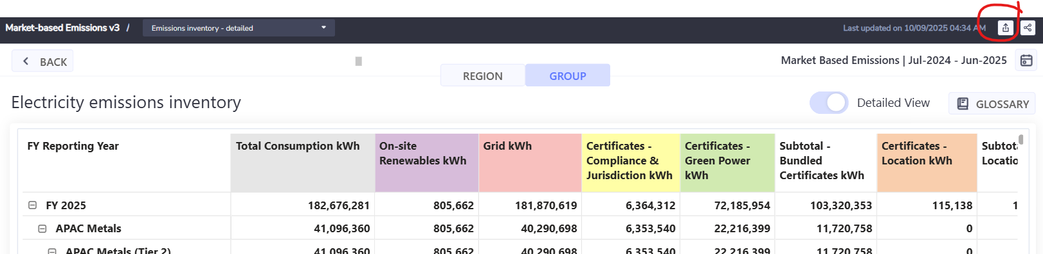

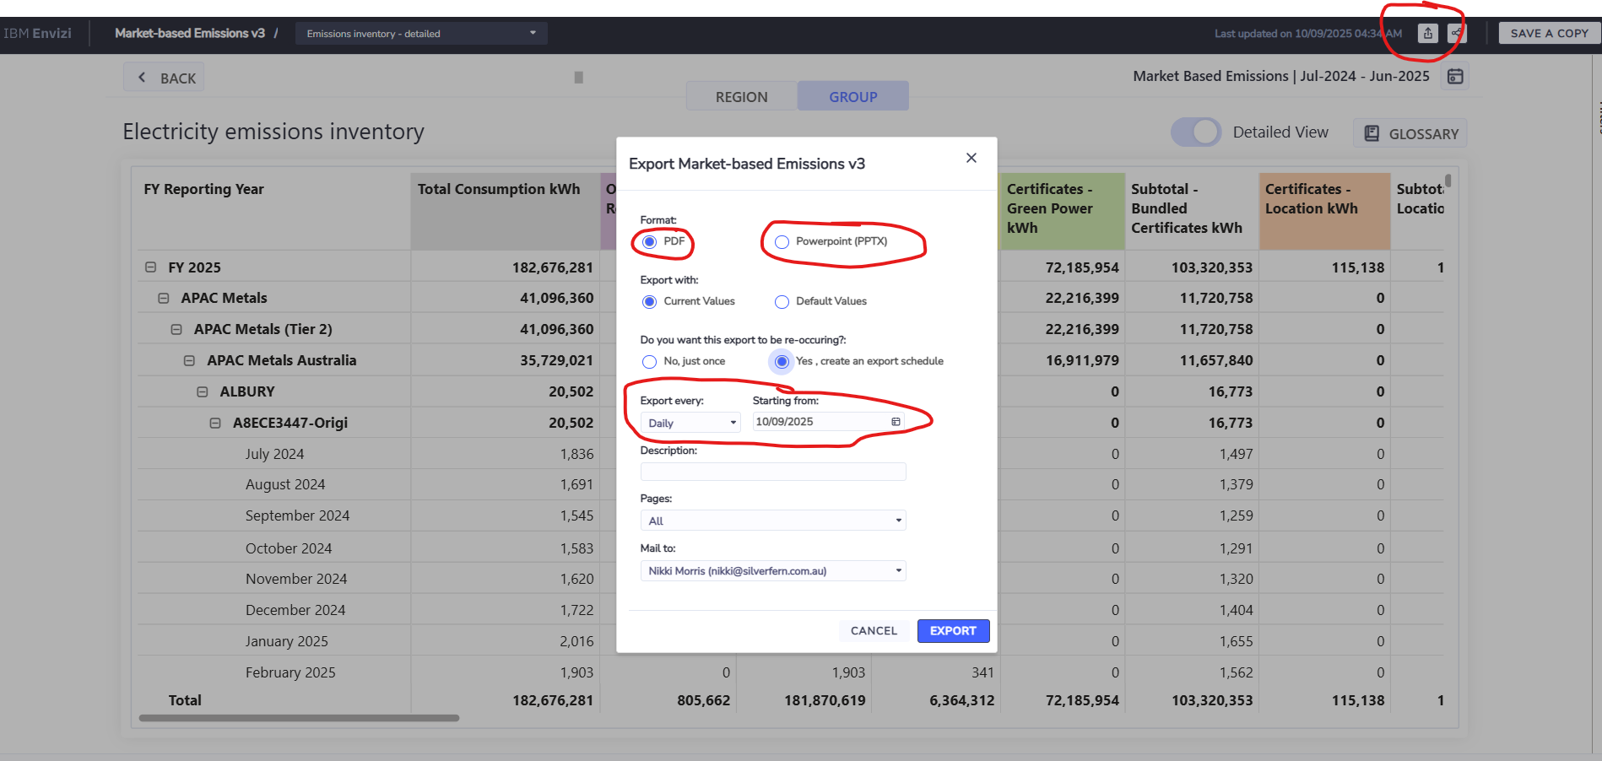

When this exports to pdf, the table to the right is completely cut off.
