Issue
Currency values are displayed according to the display mask of the user’s default currency rather than the record currency’s display mask. The application should use the record currency’s display mask.

Example
I will show an example by setting the default currency to and US Dollars and Won, and viewing a record with Australian Dollar amounts.
Summary of results are
- Case 1 - User’s currency is US Dollars
  - Amounts are displayed correctly with dollars and cents
- Case 2 - User’s currency is Won
  - Amounts are rounded up to nearest whole dollar

This is how the UOM records are set up:
- US Dollars – The user’s currency in Case 1. The Display Mask allows dollars and cents.
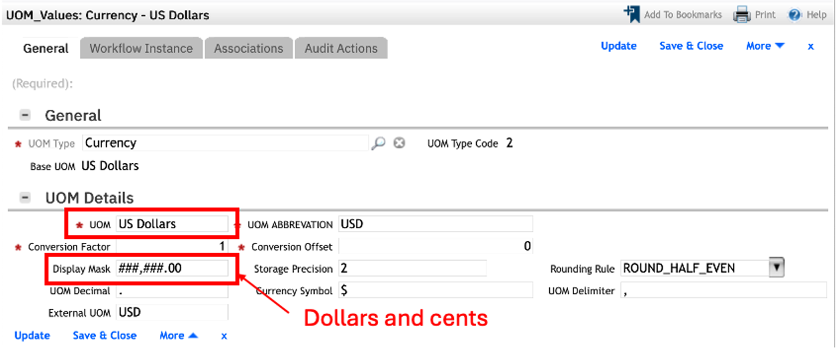
- Won – The user’s currency in Case 2. The Display Mask is whole numbers only.
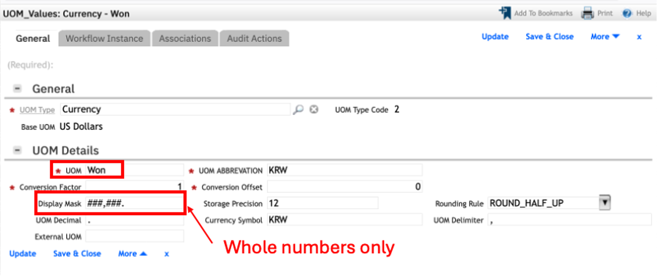
- Australian Dollar – The currency of the record to view.
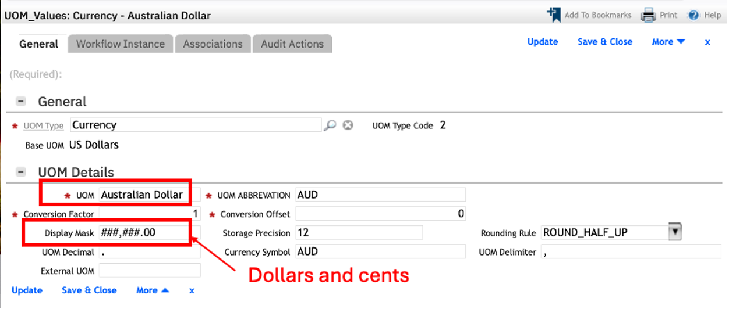

Case 1 – User’s currency is US Dollars and they see Australian Dollar amounts correctly.
- The user’s currency is US Dollars.
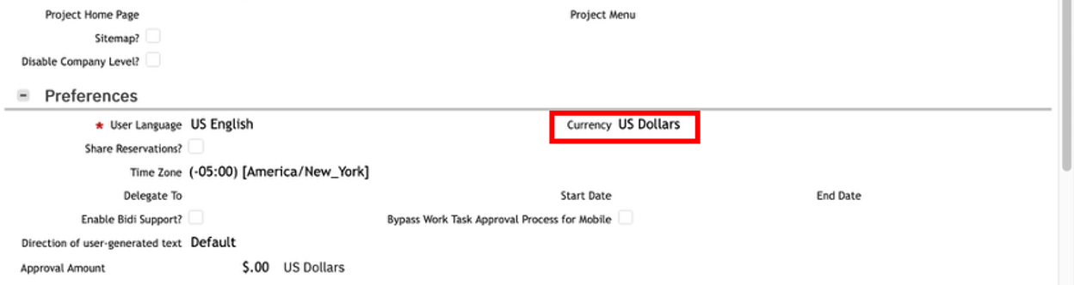

- Open a record that is in Australian Dollar. The Actual Total Cost is AUD680.66. This is correct.
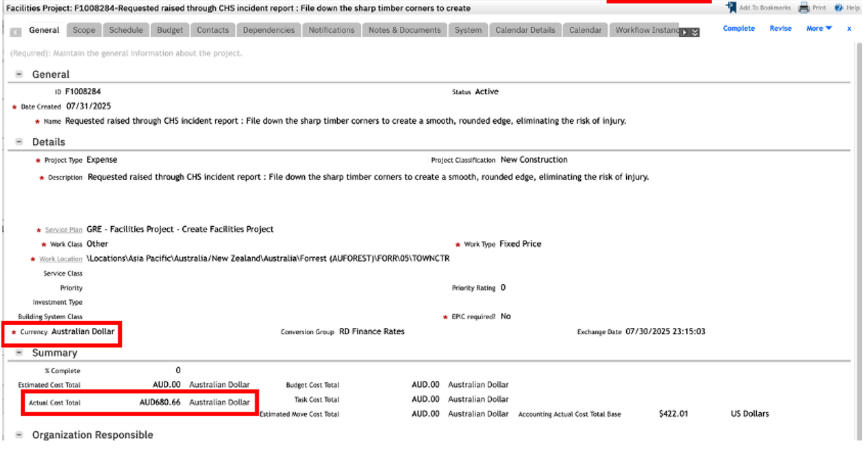

Case 2 – User’s currency is Won and they see Australian Dollar amounts rounded to nearest dollar.
- Set the user’s default currency to Won.
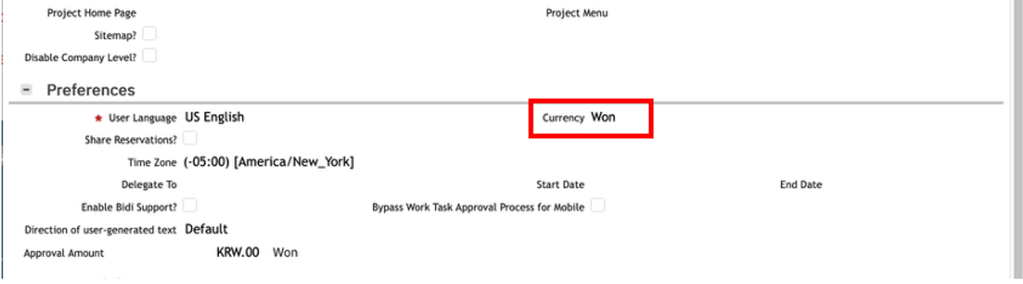

- Log out and log back in.
- View the same record as Case 1. The Actual Cost Total is now displayed as AUD681., which is AUD680.66 rounded to the nearest dollar.
Since the currency of the record is Australian Dollars, it should display AUD680.66 regardless of the user’s default currency.
