- With Manage 9.1 the banner, headers and toolbars are based on the modern Graphite UI
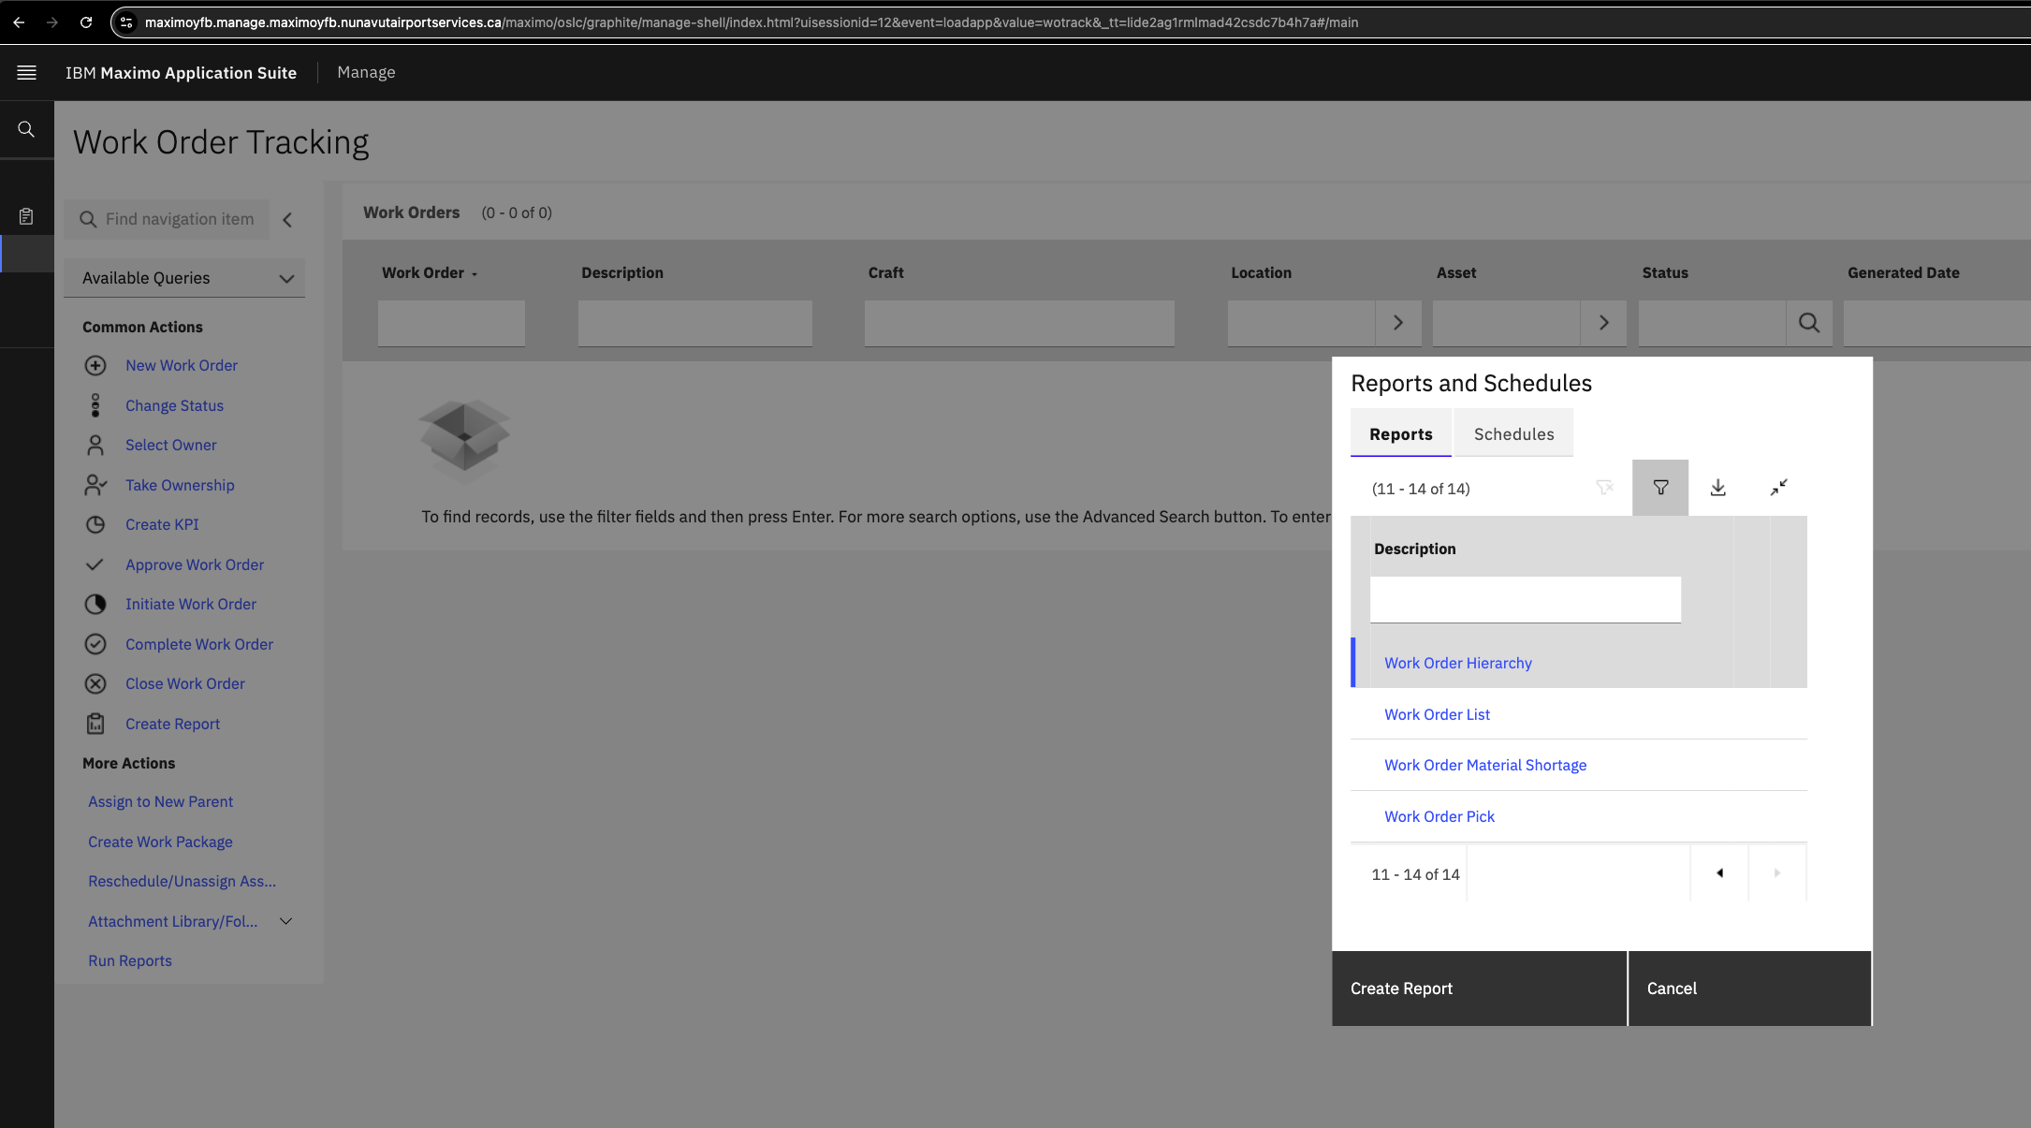

- However, when a report is launched (out of the box or custom) the banner, header and toolbar are from Maximo 7.6 version and not aligned.
