RFE Request for improvement to “Identify” tool in Spatial Map dialogue Nov. 7, 2025
With the introduction of Maximo Application Suite 9.x, the map functionality (map tools) in spatially enabled modules was significantly impacted. Our organization is maintaining over 9000 miles of underground pipe and connecting structures (manholes, inlets, pumps, etc). Users are assigned 100+ work orders for preventive maintenance of these assets. They rely upon the spatial map display to help them verify the correct asset in the field; and to identify assets from the map for reference on other work.
With the upgrade, the ”identify” tool now defaults to a “tolerance” value expressed numerically. There is no frame of reference for the units (map units, pixels?) and no ability to restrict the scope of the tool in a meaningful way when working in a tightly populated area.
As seen in the examples below, the user has lost the ability to reference the cursor position and the scope of the tool when actively seeking data from the map interface.
Previous 7.x version display example:
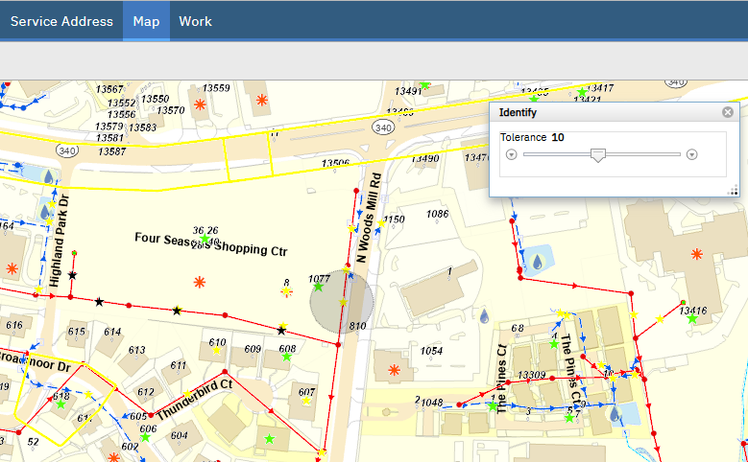
IBM Maximo Spatial Asset Management 7.6.1.1-20250121-1142 Build 20220818-2016 DB Build V7611-24 HFDB Build HF7611-22

Current version 9.x example:
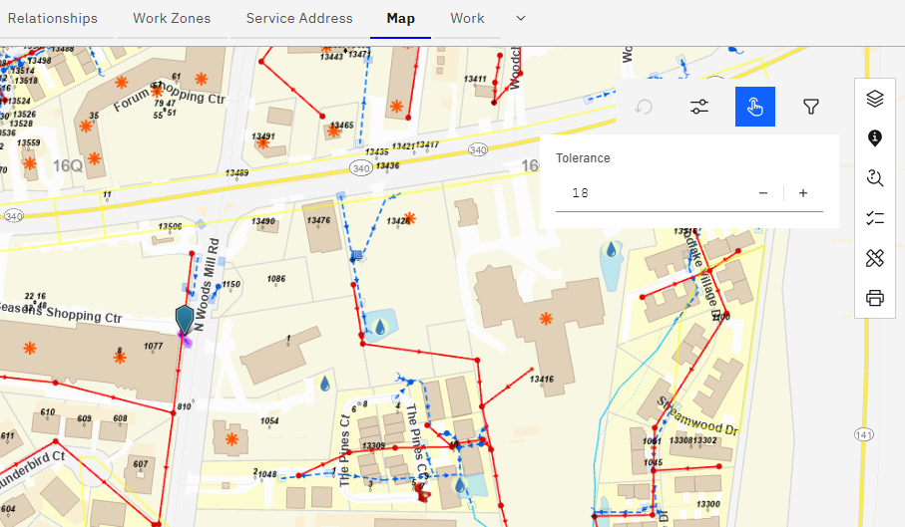
IBM Maximo Spatial 9.0.22 Build 20250514-2050 DB Build V9000-09 HFDB Build HF9000-03
*****
Reported to product support as Case number TS020321495 09/17/25
MSD user request: REQ027914
IBM customer number 5777281

